Appendix I
Flare Incidents

Recommended procedures and guidance for flare case planning are provided in this Appendix. Flare Sighting Check Sheets start on I-24. (These sheets may also be found in Appendix G.)

I.1 Flare Incidents
I.1.1 Response to Flares
I.1.2 Importance of Accurate Information
I.1.3 Importance of a Prompt Response
I.1.4 Skills Needed for Taking a Flare Sighting Report

I.2 Definitions
I.2.1 Meteorological Visibility
I.2.2 Nominal Range
I.2.3 Luminous Range
I.2.4 Geographic Range

I.3 Obtaining Sighting Data
I.3.1 Reporting Source
I.3.2 Flare Characteristics
I.3.3 Helpful Information to Obtain

I.4 Estimating Distances
I.4.1 Angle Above Horizon
I.4.2 Angle Below Horizon
I.4.3 Angle Measured From Origin to Apex
I.4.4 Limiting Factors

I.5 Determining a Datum Area
I.5.1 Single Reporting Source
I.5.2 Multiple Reporting Sources
I.5.3 Search Planning

(This page intentionally blank)

Section I.1
Flare Incidents

I.1.1 Response to Flares
Red and orange flares are recognized as marine and aviation emergency signals, and they must be treated as a distress and responded to unless available information indicates otherwise. Unresolved (insufficient information to either close or suspend) red or orange flares require first-light searches. Continued searches and searches in response to other than red or orange flares will depend on the specifics of the case.

I.1.2 Importance of Accurate Information
The nature of flare distress signaling makes planning and execution of searches difficult due to wide variations in flare types, possible altitudes, skill and position of the reporting source, and weather as well as many other factors. For that reason, the accuracy of the initial information received from a reporting source is most critical. For example, a hand-held flare in a recreational boat seen on the horizon by a reporting source standing on the beach will be approximately 7 nm away, while a parachute flare rising to 1200 feet and seen on the horizon by the same reporting source could be more than 18 nm away.

I.1.3 Importance of a Prompt Response
As with all SAR cases, a prompt, thorough and proper response yields the greatest chance of a rescue. Otherwise, the search planner may have no choice but to expand and/or extend the search, dispatching additional SRUs to search larger areas.

I.1.4 Skills Needed for Taking a Flare Sighting Report
Persons taking a flare report should have a good understanding of the applicable principles and procedures. The inquiry process requires patience and good interpersonal skills since reporting sources are rarely familiar with the terminology or procedures for prosecuting flare sightings. A flare reporting checklist must be used to ensure that a proper report is taken to get all the facts.

(This page intentionally blank)
Section I.2

Definitions

I.2.1 Meteorological Visibility
The greatest distance at which a black object of suitable dimensions can be seen and recognized by day against the horizon sky, or, in the case of night observations, could be seen and recognized if the general illumination were raised to the normal daylight level.

I.2.2 Nominal Range
The maximum distance at which a light can be seen in clear weather as defined by the International Visibility Code (meteorological visibility of 10 nautical miles).

I.2.3 Luminous Range
The maximum distance at which a light can be seen under existing visibility conditions. Luminous Range does not take into account the elevation of the light, the observer’s height of eye, the curvature of the earth, or interference from background lighting.

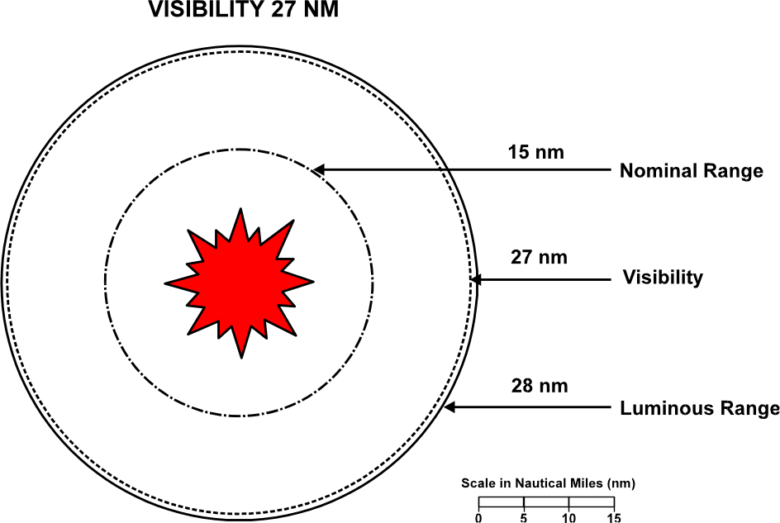

Figure I-1a Luminous Range and Visibility, example with visibility of 27nm

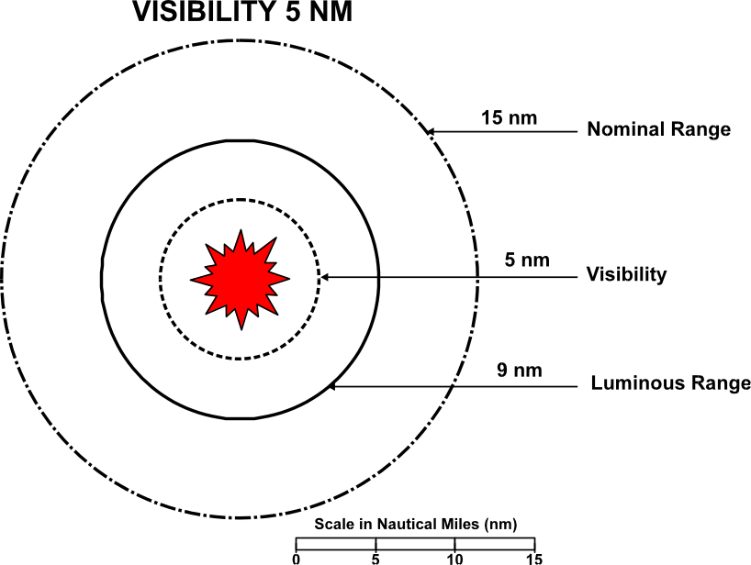

Figure I-1b Luminous Range and Visibility, example with visibility of 5 nm

I.2.4 Geographic Range
The maximum distance at which the curvature of the earth permits a light to be seen from a particular height of eye without regard to the luminous intensity of the light. Geographic range can be determined by adding the distance of the horizon from the observer and the distance of the horizon from the light.

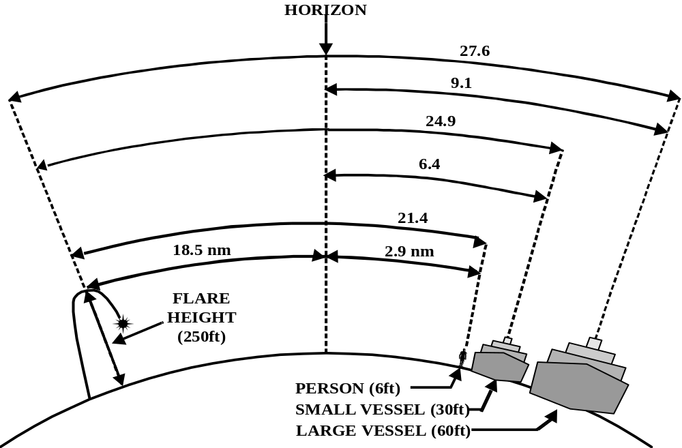

Figure I-2 Geographic Range of a flare by height of eye

Section I.3
Obtaining Sighting Data

I.3.1 Reporting Source
The following information about the reporting source should be obtained:

I.3.1.1 Position. Reporting source position is the point from which distance and direction are measured. Attempt to obtain: latitude/longitude; bearing and range from a prominent landmark; or street address.
Note: Many local law enforcement units and Coast Guard Auxiliarists have hand-held GPS receivers. They are available and prevalent among the public at large. If this technology is available, consider dispatching an auxiliarist or a police officer to the reporting source location to obtain a GPS position. This will reduce the position error of the reporting source to virtually zero.

I.3.1.2 Height of eye. To most accurately estimate the range to the flare from the reporting source, the height of eye of the reporting source is important. If the reporting source is in a tall building, record the floor number and estimate 10 feet per floor above the height of eye at ground level.

I.3.1.3 Personal information of the source. Obtain the name of the reporting source and establish a means of further contact. Request that the reporting source remain on scene or return to the position of the sighting in order to assist in the search and rescue unit (SRU) placement. A reporting source who provides a way to be contacted or is willing to remain on the scene or return to the scene is more credible than one unwilling to do these things.

I.3.2 Flare Characteristics
Characteristics can aid in determining the distress location, and may correlate with other sightings, phenomena, or military exercises. Flares can be identified primarily by trajectory and duration of burn. As Table I-1 describes, meteor flares have a rapid rise and rapid fall. Parachute flares exhibit a rapid rise and slow descent. These characteristics can be observed by an astute reporting source. Judging the height of the flare is much more difficult, even for a trained eye. It is important to note that the height of a flare significantly affects the size of the search area. If the type of flare can be determined to be a meteor flare, rather than a parachute flare, the search area can be significantly reduced since meteor flares can achieve only about 1/3 the maximum height of parachute flares. Parachute flares are rare among recreational boaters. If a flare is determined to be a parachute flare, a major search effort may be needed to cover a large geographic area. Table I-1 lists characteristics by flare type, but additional information can also be helpful. As much of the following information as possible should be collected:

I.3.2.1 Color. It is critical in assessing urgency. Red and orange flares must be treated as distress cases until proven otherwise.

I.3.2.2 Number of flares, time(s) of sighting(s), and intervals between flares.

I.3.2.3 Apparent origin of the flare. Did the reporting source see where the flare came from? If so, was it near the horizon or definitely between the reporting source and the horizon? Were any objects illuminated by the flare? If so, what were they?

I.3.2.4 Trajectory. The nature of the flare’s trajectory is an extremely important clue. Every effort should be made to obtain accurate answers to the following questions: Did the reporting source see the flare both rise and fall? Rising only? Falling only? What were the rates of rising and falling (rapid rise and fall, rapid rise, slow fall, etc.)? Was the trajectory steep (mostly vertical) or flat (mostly horizontal)? Answers to these questions will help establish the type of flare and therefore the possible heights it could reach as well as provide some additional clues about its location. Table I-1 shows the characteristics of some common types of flares.

I.3.2.5 Time interval and duration of burn. This also aids in determining the type of flare.

Table I-1 Flare Characteristics

TYPE | TRAJECTORY | AVERAGE HEIGHT | CANDLEPOWER NOMINAL RANGE
METEOR* | RAPID RISE AND DESCENT | 250 - 400 FT | 10000 - 30000  15 - 17 NM
PARACHUTE** | RAPID RISE/SLOW DESCENT | 1000 - 1200 FT` | 20000 - 40000  14 - 20 NM
HAND-HELD*** | STEADY | ASSUME 10 FT | 500 - 15000  8 - 16 NM
*Meteor flares have no minimum altitude requirements.
**Parachute flare requirements by SOLAS: 300 meters (990') height, 30K candlepower.
***Hand-held candlepower requirements: USCG-500; SOLAS-15000.

I.3.2.6 Angle of observation. Often the reporting source will not be able to accurately estimate the angle of elevation without some assistance. The angle of elevation is the angle measured from the horizon to the top of the trajectory.

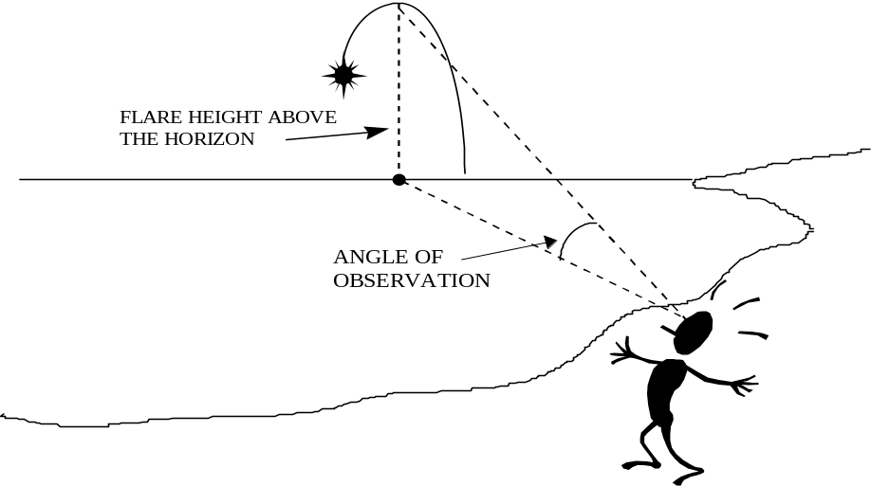
Figure I-3a Example of angle when flare origin is beyond the horizon and unobserved

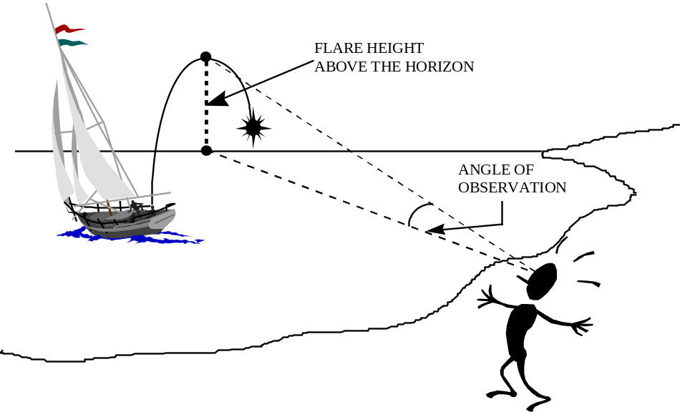
Figure I-3b Example of angle when flare origin is observed

If the origin of the flare is observed, the reporting source may measure the angle from the origin to the top of the trajectory. This method of determining the angle may be helpful when the horizon cannot be seen or used as a reference.

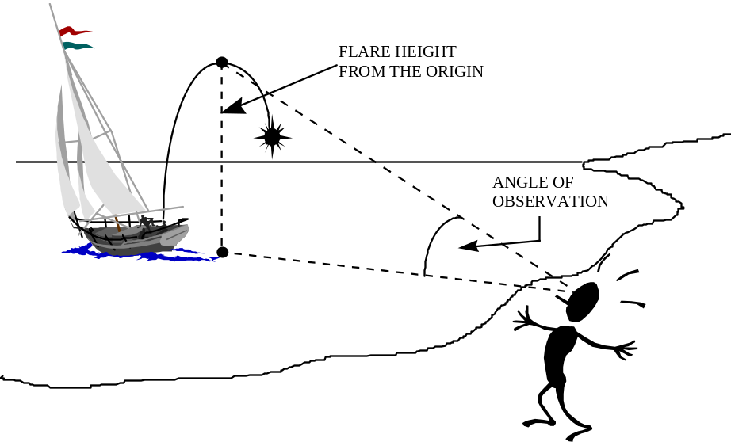

Figure I-3c Example of angle measured from flare origin to top of trajectory

The person taking the report should be sure to determine exactly what angle is measured. “Is the angle from the horizon to the top of the trajectory or from the point where you saw the flare take off to the top of the trajectory?” This distinction will become important in the planning stage.

(a) A major point to remember is that for any flare sighting with an angle of elevation of more than 8 degrees, the distance of the flare from the reporting source is less than 1.4 nm.
(b) Closed Fist Method. A closed fist held at arm’s length with the thumb side up represents approximately 8 degrees of arc.

Unless the reporting source’s height of eye is greater than the height of the flare at the top of its trajectory, the flare will normally appear to rise above the horizon. In this situation, when the bottom of the fist is aligned on the horizon relatively accurate estimates of small vertical angles can be made. Brief the reporting source on this reference system. “If you hold your fist at arm’s length, with your thumb on top and the bottom of your fist on the horizon, was the top of the trajectory above or below the top of your fist?” If the flare was sighted below the top of the fist, have the reporting source attempt to more accurately estimate the angle with the horizon.
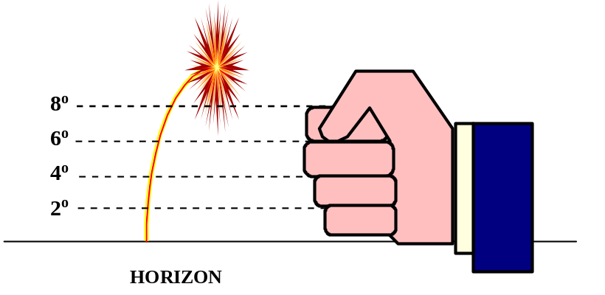

Figure I-4a Fist Method for measuring flare angles above horizon

An estimate of three fingers or half a hand can be extremely useful. Obtain the final estimate in terms such as “not less than ½ hand and not more than 1 ½ hands.” Convert number of fingers or fractions of hands to degrees based on Figure I-4a above.
Estimates collected from untrained reporting sources are necessarily fraught with uncertainty. Search planners must carefully question reporting sources of flares to remove as much of the uncertainty as possible without encouraging the reporting source to report unjustifiably precise estimates. Search planners must then develop search plans that reflect the actual uncertainties. Failure to do so can result in searching either too small or too large an area and missing the target. An estimate of “definitely less than a fist, but definitely more than a quarter of a fist,” translated to degrees as definitely less than 8 degrees but more than 2 degrees, can tremendously limit the datum area as compared with, “I can only say less than a fist.” The objective is to “bracket” or estimate the bounds of the area containing the sighted flare without covering substantially too much or too little area.
With hand-held flares, and even meteor flares if the reporting source is high enough, the flare may not rise above the visible horizon if it originates between the reporting source and the horizon. In this case, the reporting source should be asked to align the top of the index finger with the horizon and estimate the apparent distance below the horizon using the fist method described above. See Figure I-4b.

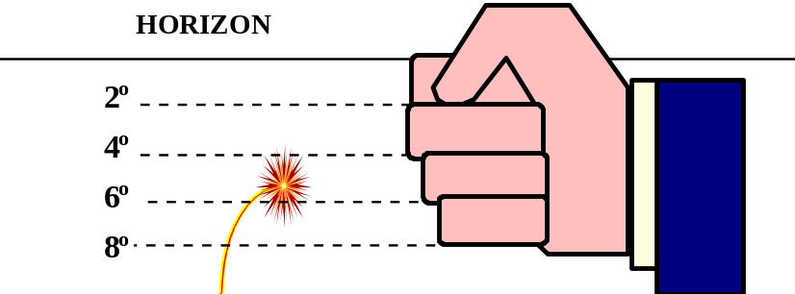

Figure I-4b Fist Method for measuring flare angles below horizon

I.3.2.7 Bearing from the reporting source. There are several means by which a bearing may be estimated:

- clock method (Figure I-5 shows how to determine the line of bearing by referring to the direction as points on a clock, with twelve o’clock being perpendicular to the reporting source in relation to the shore line or building where the reporting source is located. Most buildings along the shoreline will be aligned with the shore. If the “clock” is being referenced to a building’s walls that are not aligned with the shoreline, then the search planner will need to determine the orientation of the building.)
- gyro/magnetic compass,
- reference object,
- seaman’s eye, or
- a guess.
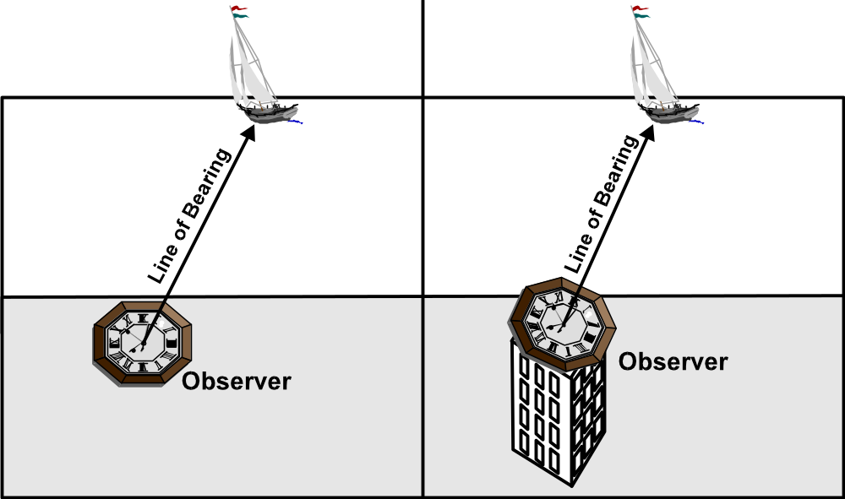

Figure I-5 Clock Method for determining bearing. Reporting source aligned with shore (left), bearing 1 o’clock; reporting source not aligned with shore (right), bearing 12 o’clock.

If the reporting source has difficulty in confidently estimating direction, amplifying information, such as the following, should be obtained:

- direction relative to the street direction,
- direction relative to a line passing through reporting source’s position and another prominent landmark or reference point,
- identity of prominent landmarks on either side of the line of bearing from the reporting source to the flare,
- direction relative to the trend of the shoreline in that area, or
- direction relative to the line between the reporting source and the moon or a star or constellation the reporting source can confidently identify.

The search planner should estimate the degree of uncertainty in the form of bearing errors to the right and left of the reported bearing. These will establish rightmost and leftmost bearings from the reporting source. Datum estimates must reflect real doubts. Failure to reflect realistic uncertainties can lead to false confidence in a search’s chances for success.

I.3.2.8 Distance. Estimating distance directly from an observation, without recourse to vertical angles and tables, is difficult for even an accomplished seaman. Data developed in research conducted by the Coast Guard Research and Development Center (Robe, R.Q., et al., 1985) has shown that in most cases reporting sources tend to underestimate distance. Most estimates of distance should not be given significant consideration unless the reporting source is basing the estimate on the distance to a known object on or near the flare’s line of bearing.

I.3.3 Helpful Information to Obtain

I.3.3.1 Aircraft/vessels seen in vicinity. If the reporting source can see the vessel being illuminated by the flare then the flare is inside the horizon. If an aircraft was seen, it may be possible to correlate this report with reports, if any, from the aircraft. It may also be possible to correlate the report with aircraft positions (from radar or radar playback) at the time of the sighting.

I.3.3.2 Obstructions. Information about obstructions can be of value in several ways.

- Gauging distance. For example, a flare seen to rise/descend in front of an island clearly indicates the maximum distance to the flare is the distance to the island. If seen behind an obstruction it clearly indicates the minimum distance is the obstruction distance.
- Determining direction. Flares seen over or between identifiable obstructions give the reporting source a reference for determining direction.
- Estimating angle of elevation. For example, a flare seen over the top of a nearby stand of 60 ft trees by a reporting source standing on the ground (assuming level terrain) means the flare could not have been fired from a distance very far beyond the tree line.

I.3.3.3 On scene weather and visibility. This can be useful in limiting the area to be searched. Ascertain how visibility was determined, such as from objects that are just visible at a known range. Keep in mind that horizontal visibility factors, such as ground fog, may not limit the visibility for a meteor or parachute flare as much as for a hand-held flare.

Section I.4
Estimating Distances

Estimating the distance of the flare from the reporting source is one of the more difficult problems in search planning. Flare sightings are generally made by untrained, inexperienced reporting sources. While any information they can provide is helpful, it also has a large associated uncertainty. However, the reporting source is not the only source of uncertainty. The actual height of the observed flare at the top of its trajectory is also subject to a large uncertainty. For reports of less than 4 degrees (1/2 fist), the range of distances increases very rapidly. Planners must use all means to obtain accurate information to establish a manageable search plan.
Before presenting the actual step-by-step procedures for using the distance tables for estimating minimum and maximum distances from the reporting source, an explanation of the rationale behind these procedures and tables is in order.

I.4.1 Angle Above the Horizon
If the flare is observed above the horizon at the apex of its trajectory, then its distance from the reporting source will depend on the reporting source’s height of eye, the observed angle above the horizon and the height of the flare above the surface. Assuming that information about the first two factors can be obtained from the reporting source, this leaves the height of the flare as the only “unknown.” For flares that are fired into the air, the maximum height is assumed to be 1200 feet for parachute flares and 500 feet for meteor flares. The minimum height for both types of flare is assumed to be 250 feet or 10 feet above that of the reporting source for heights of eye greater than 240 feet. A flare that rises only 250 feet must be much closer to a given observer (e.g. height of eye 20 feet) in order to produce a given observed angle above the horizon (e.g. 1 degree) than a flare rising to 1200 feet which produces the same angle from the same point of observation. The distance in the first case is 2.31 nm while the distance in the second case is 10.98 nm. Therefore, the minimum distance table (Table I-2a) is based on the assumed minimum flare heights and the maximum distance tables (Tables I-2b and I-5) are based on the assumed maximum flare heights. The procedures presented later in this appendix also show how to account for realistic limitations in the ability of reporting sources to estimate vertical angles and to identify different types of flares.
Example: If a reporting source with a sextant whose height of eye is 20 feet observes a flare rise to one degree above the horizon, it would be about 11 nm away if it rose to 1200 feet but only 2.3 nm away if it rose to only 250 feet. However, if the reporting source could only estimate the angle as between 0.5 and 2 degrees, then the minimum and maximum ranges would become 1.2 nm and 19.2 nm.

I.4.2 Angle Below the Horizon
If the reporting source is high enough, and the flare is low enough at the top of its trajectory, then it will not appear to rise above the horizon. If this happens, then the flare must be between the reporting source and the horizon. However, for large heights of eye, the distance to the horizon can be quite substantial. The datum area can be reduced significantly if angles below the horizon can be measured or estimated. In this case, for a given height of eye and angle below the horizon, the higher the flare rises above the surface, the closer it must be. This is exactly opposite to the situation described in the preceding paragraph. Since a flare that does any rising at all and fails to cross the horizon line must be quite close, the minimum distance was computed by assuming the maximum flare height was 10 feet below that of the reporting source for heights of eye up to 240 feet and 250 feet for greater heights of eye. A minimum flare height of zero was used to determine the maximum distance from the reporting source.

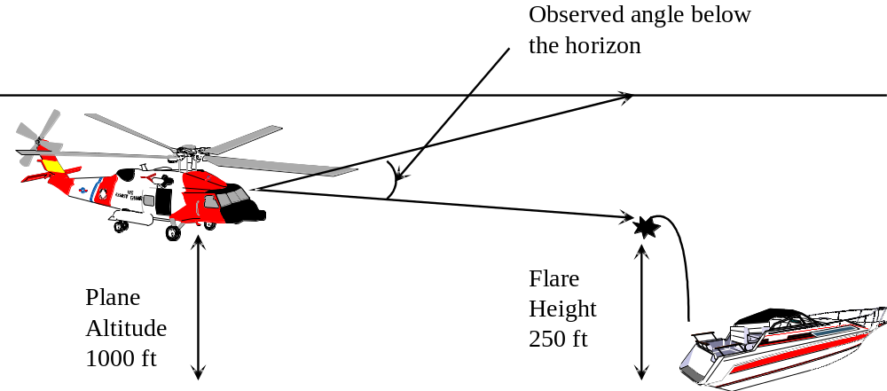

Figure I-6 Observed angle below the horizon

Example: A reporting source with a sextant and a height of eye of 300 feet observes a flare rise to within one degree of the horizon. If the flare’s maximum height was 250 feet, it would be only 0.36 nm from the reporting source. If the maximum height was zero and it never actually left the surface, it would be about 2.2 nm away. However, if the reporting source could only estimate the angle as between 0.5 and 2 degrees below the horizon, then the minimum and maximum distances become 0.2 nm and 3.6 nm.

I.4.3 Angle Measured from Origin to Apex
The reporting source may not have a visible horizon to use as a reference for measuring angles, but may be able to estimate the angle between the origin and maximum height of the flare. Because the origin can be seen, the flare must be closer than the distance of the horizon, if the horizon could be seen. However, as stated before, for larger heights of eye the distance of horizon can be many miles away. To determine the maximum distance, and limit the datum area, a flare height of 1200 feet is assumed; and to determine the minimum distance, a flare height of 250 feet is assumed. The reporting source’s height is not a factor in these calculations for several reasons. First, it is assumed that the earth is flat between the reporting source and the flare. Thus the horizon, which was used as a reference in the previous methods and whose distance from the reporting source varied with the reporting source’s height of eye, is not a factor. Second, even though there are slight differences in the geometry and computed distances for different heights of eye, for the flat earth model and the heights and distances involved, these differences are insignificant. The solution found by using zero for the assumed height of eye and the simple trigonometry of right triangles produces sufficiently accurate results.
Example: If a reporting source with a sextant observes a flare rise to an observed angle of one degree from the flare origin to the apex, it would be about 11.3 nm away if it rose to 1200 feet but only 2.4 nm away if it rose to only 250 feet. However, if the reporting source could only estimate the angle as between 0.5 and 2 degrees, then the minimum and maximum distances become 1.2 nm and 22.6 nm. Figure I-7 illustrates this concept for several vertical angle observations.

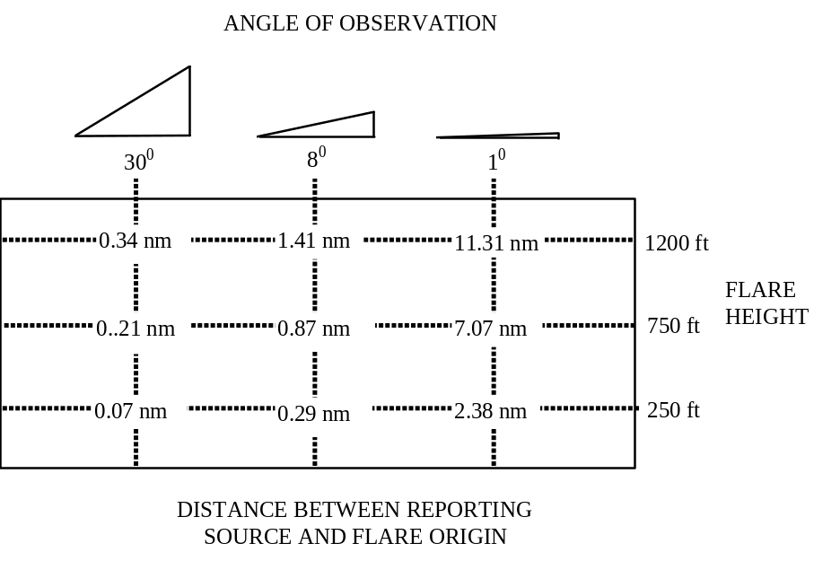
Figure I-7 Relationship of Vertical Angles to Distances (Flat Earth)

I.4.4 Limiting Factors
I.4.4.1 Geographic range. The geographic range is the absolute limiting factor for the maximum distance of all flares from the reporting source. Only rarely will flares be sighted at such an extreme range.
I.4.4.2 Luminous Range. The maximum distance may be limited by the luminous range of the flare at the time and place of the sighting. There is a complex relationship between luminous range and meteorological visibility. Because a flare is a bright source of light, it can be seen at distances greater than the meteorological visibility. As meteorological visibility decreases, so does a flare’s luminous range. However, the relationship between the two changes dramatically. As shown in Figure I-8, a flare with a nominal luminous range of 20 nm may have actual luminous ranges from less than two to nearly five times the meteorological visibility. If on-scene visibility is known to be such than even the brightest flare could not be seen at a distance equal to the maximum distance estimated by other means, some portion of the far end of the datum line or area may be eliminated. For a flare having a nominal luminous range of 20 nm, the table below shows the actual luminous range under various visibility conditions. Figure I-14, discussed later, may be used to estimate luminous ranges in virtually all situations of practical interest.

On-scene Meteorological Visibility |  | Luminous Range
0.25 | nm (500 yards) | 1.2 | nm
1 | nm | 3.5 | nm
2 | nm | 6 | nm
5 | nm | 12 | nm
10 | nm | 20 | nm
27 | nm | 40 | nm

Figure I-8 Example of relationships between meteorological visibility and luminous range
(for a flare with 20 nm nominal luminous range)

Visibility can be a significant limiting factor, but to be valid, it must be accurately determined for the immediate area of the reporting source at the time of the sighting. The average reporting source may misjudge distances to a visible object, and hence misjudge visibility, especially at night. Horizontal visibility may not have the same diminishing effect on meteor or parachute flares, as these flares may be seen above a ground fog or ground haze.

I.4.4.3 Obstructions. If a flare was definitely seen to rise/fall in front of an obstruction, its distance from the reporting source can be no greater than the distance to the obstruction. Similarly, if the flare is seen behind an obstruction, it can be no closer than the obstruction.

I.4.4.4 Position of origin or point last seen relative to horizon. If the reporting source saw the flare rise and fall between his position and the horizon, and can confidently estimate whether the flare rose from the surface or fell to the surface ¼, ½, ¾, of the distance to the horizon, or near or at the horizon, this information can reinforce other datum indicators or limit the maximum distance. Table H-41 (Table 12 of The American Practical Navigator (Bowditch, ed. 1995)) provides distance of the horizon for various heights of eye. When using this method, caution should be exercised when limiting maximum distance to a value significantly less than the distance of the horizon.
Section I.5
Determining a Datum Area

I.5.1 Single Reporting Source

I.5.1.1 Plot the reporting source’s position on a chart and draw a circle of radius equal to the reporting source’s probable position error around that point.

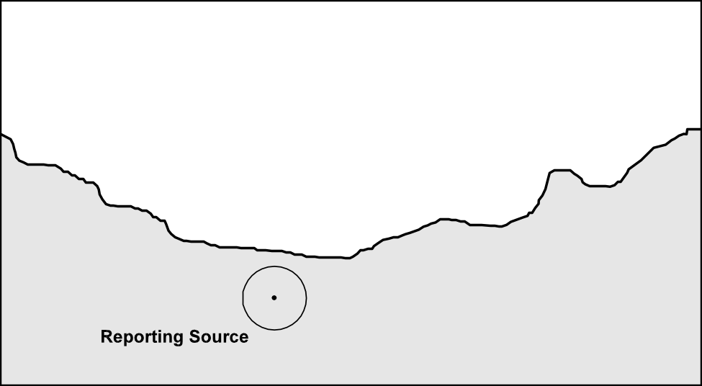

Figure I-9 Step 1: Plotting reporting source position and position error

I.5.1.2 Draw the line of bearing (LOB) along which the reporting source sighted the flare, with lines on either side showing the probable bearing error. The LOB should extend at least 20 nm toward the flare, and far enough behind the reporting source to intersect the position error circle on the side opposite the flare.

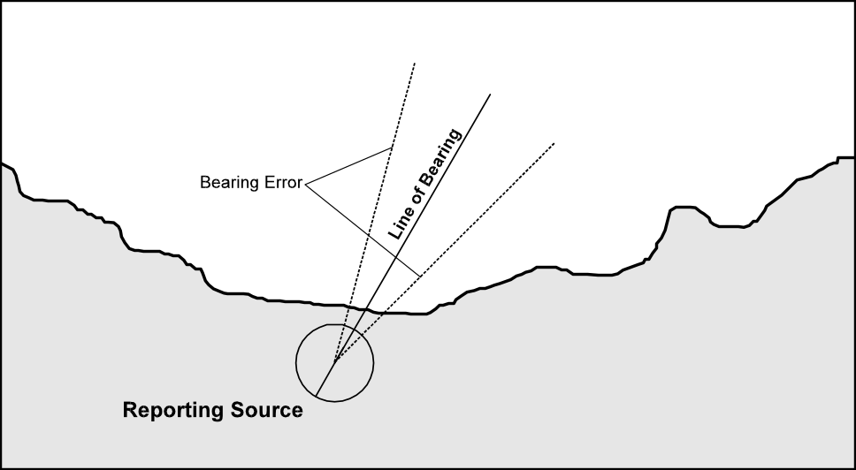
Figure I-10 Step 2: Plotting line of bearing and bearing error
I.5.1.3 Draw a line through the reporting source’s position perpendicular to the flare’s LOB. At each point where this line crosses the probable position error circle, draw a line parallel to the corresponding bearing error line.
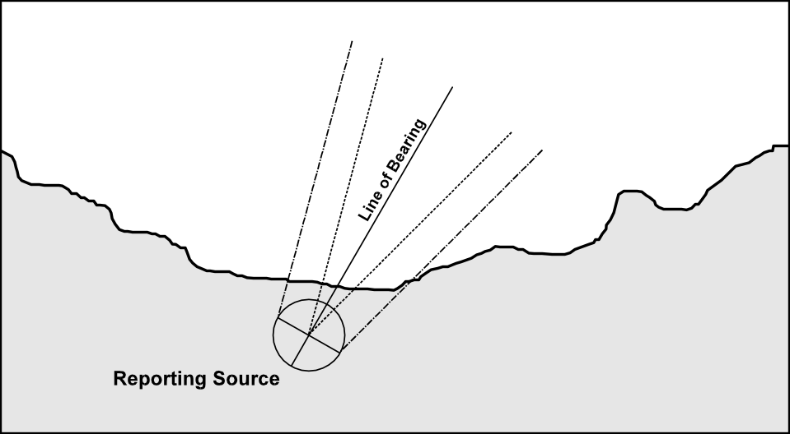
Figure I-11 Step 3: Bearing error including position error
I.5.1.4 Compute minimum and maximum distances by identifying which type of angle has been reported, convert fractions of a fist or numbers of fingers to degrees, and use these angles along with the reporting source’s height to reference the appropriate set of minimum and maximum distance tables as described in (a) through (e) below. Determine if on-scene visibility can limit the maximum distance, as described in (f) below.
It is important to note that if a range has been given for the observed angle, the maximum angle should be used with the minimum distance table and the minimum angle should be used with the maximum distance table. For example, suppose the reporting source states that the flare was “definitely less than a fist, but definitely more than a quarter of a fist.” This would be translated to a maximum angle of 8 degrees and a minimum angle of 2 degrees. Use 8 degrees to determine minimum distance, and 2 degrees to determine maximum distance.

(a) If the angle is reported to be above the horizon, use Tables I-2a and I-2b as follows:

- Table I-2a, Minimum Distance to Flare, Angle of Observation Above the Horizon, determines the closest distance to the flare from the reporting source. Determine the minimum distance by using the maximum observed angle above the horizon. Angles can be determined by converting fractions of a fist to degrees.
Example: A flare seen ½ of a fist above the horizon, or at an angle of observation of 4 degrees, could be as close as 0.57 nm for a reporting source at 10ft.

- Table I-2b, Maximum Distance to Flare, Angle of Observation Above the Horizon, determines the maximum distance to the flare from the reporting source. Determine the maximum distance by using the minimum observed angle above the horizon, converted from fraction of a fist to degrees.
Example: A flare seen ¼ of a fist above the horizon, or at an angle of observation of 2 degrees would have a maximum distance of 5.63 nm for a reporting source at 10ft.
Given this range of observed angles, the flare must be roughly between 0.6 nm and 5.6 nm from the reporting source - a separation of only 5 nm. A more conservative estimate, obtained by “rounding” the minimum distance down and the maximum distance up the next 0.5 nm increment, would be 0.5 to 6.0 nm from the reporting source.

(b) If the angle is reported to be below the horizon, use Tables I-3a and I-3b as follows:

- Table I-3a, Minimum Distance to Flare, Angle of Observation Below the Horizon, determines the closest distance to the flare from the reporting source. Determine the minimum distance by using the maximum observed angle below the horizon. Angles can be determined by converting fractions of a fist to degrees.
Example: A flare seen ½ of a fist below the horizon, or at an angle of observation of 4 degrees, could be as close as 0.11nm for a reporting source at 300 ft.
- Table I-3b, Maximum Distance to Flare, Angle of Observation Below the Horizon, determines the maximum distance to the flare from the reporting source. Determine the maximum distance by using the minimum observed angle below the horizon, converted from fraction of a fist to degrees.
Example: A flare seen ¼ of a fist below the horizon, or at an angle of observation of 2 degrees would have a maximum distance of 1.23 nm for a reporting source at 300 ft.
Given this range of observed angles, the flare must be roughly between 0.1 nm and 1.2 nm from the reporting source - a separation of only 1.1 nm. A more conservative estimate, obtained by “rounding” the minimum distance down and the maximum distance up the next 0.5 mile increment, would be 0.0 to 1.5 nm from the reporting source.
Caution: As angles below the horizon become small, distances increase very rapidly. For example, a flare at zero height above the water observed as 0.5 degrees below the horizon from a height of eye of 260 feet is only 3.23 nm away but such a flare on the horizon could be as far as 18.9 nm away. Only if the flare is observed to be a definite, measurable angle below the horizon should maximum distances based on Table I-3b be used. Otherwise, the distance of the horizon should be used.

(c) If the angle is reported to be from the origin up to the flare apex:
The methods used in the two situations above cannot be used if the angle of observation is determined to be from the flare origin to the flare apex. This angle requires a different set of computations. Table I-4, Distance Range for Angle of Observation from Flare Origin to Apex, should be used to calculate the distance range using the minimum and maximum angles converted from fractions of a fist.
Example: A flare seen to rise from its origin as much as one fist, or at an angle of observation of 8 degrees, could be as close as 0.29 nm for the reporting source. If the minimum angle observed was ½ of a fist, or an angle of 4 degrees, then the flare could be as much as 2.82 nm from the same reporting source. A more conservative estimate would be between 0.0 and 3.0 nm from the observer.
(d) If the flare is determined to be a meteor flare:

- To determine the minimum distance to the flare, Table I-2a, Minimum Distance to Flare, Angle of Observation Above the Horizon should be used as in a) above because the minimum height is still assumed to be 250 feet or 10 feet above that of the reporting source for heights of eye greater than 240 feet. It is only the maximum height that has changed.
Example: A flare seen ½ of a fist above the horizon, or at an angle of observation of 4 degrees, could be as close as 0.57 nm for a reporting source at 10ft.
- If it can be determined from the description of the flare’s trajectory that it is a meteor flare, Table I-5 Maximum Distance for Meteor Flares, Angle of Observation Above the Horizon should be used to determine the maximum distance. Using this table will significantly reduce the search area and should only be used in those cases where the flare’s type is not in question. Determine the maximum distance by using the minimum observed angle above the horizon, converted from fraction of a fist to degrees.
Example: A flare seen ¼ of a fist above the horizon, or at an angle of observation of 2 degrees would have a maximum distance of 2.35 nm for a reporting source at 10ft.

Given this range of observed angles, the flare must be roughly between 0.6 nm and 2.4 nm from the reporting source - a separation of only 1.8 nm. A more conservative estimate, obtained by “rounding” the minimum distance down and the maximum distance up the next 0.5 nm increment, would be 0.5 to 2.5 nm from the reporting source.
Note: Tables I-3a and I-3b, Minimum and Maximum Distance to Flare, (respectively) Angle of Observation Below the Horizon, should still be used if the reporting source can identify the type of flare as a meteor because these tables are not affected by flare maximum height. Maximum distances in Table I-3b were calculated using a minimum height of zero. For more information see section 4.B above.
(e) If the flare is determined to be a hand-held flare:

If it can be determined from the description of the flare’s trajectory (or lack of one) that it is a hand-held flare, Table I-6 Distances for Hand-held Flares should be used to determine the distance using the angle below the horizon. A flare height of 10 feet is assumed.
Example: A flare seen as much as ¾ of a fist below the horizon, or at an angle of observation of 6 degrees, could be as close as 0.14 nm for a reporting source at 100 ft. If the minimum angle observed was ¼ of a fist below the horizon, or an angle of 2 degrees, then the flare could be as much as 0.39 nm from the same reporting source. A more conservative estimate would be between 0.0 and 0.5 nm from the observer, but even this is a very small separation.
Caution: As angles below the horizon become small, distances increase very rapidly. For example, a hand-held flare at a height of 10 feet above the water observed as 0.5 degrees below the horizon from a height of eye of 100 feet is only 1.27 nm away but such a flare on the horizon could be as far as 15.4 nm away (the geographic range found by adding the distances of the horizon from 100 feet and 10 feet). Only if the flare is observed to be a definite, measurable angle below the horizon should maximum distances based on Table I-5 be used. Otherwise, the geographic range should be used at this point.
f) Determine if on-scene visibility can limit the maximum distance by using the largest appropriate nominal range from Figure I-2 and the on-scene visibility with Figure I-14 to determine the luminous range of the flare. Enter the Luminous Range Diagram (Figure I-14) from the right or left vertical scale using the flare’s nominal range. Follow the corresponding horizontal line across to the curve representing the meteorological visibility. Move vertically to read the luminous range from the top or bottom horizontal scale. For example, a flare with a nominal range of 15 nm has a luminous range of 28 nm when the meteorological visibility is 27 nm.

I.5.1.5 Show the minimum and maximum distances as arcs extending to the bearing error lines on either side of the LOB. The center point used to draw the maximum distance arc should be where the LOB intersects the position error circle on the side toward the flare. The center point used to draw the minimum distance arc should be where the LOB intersects the position error circle on the side away from the flare.

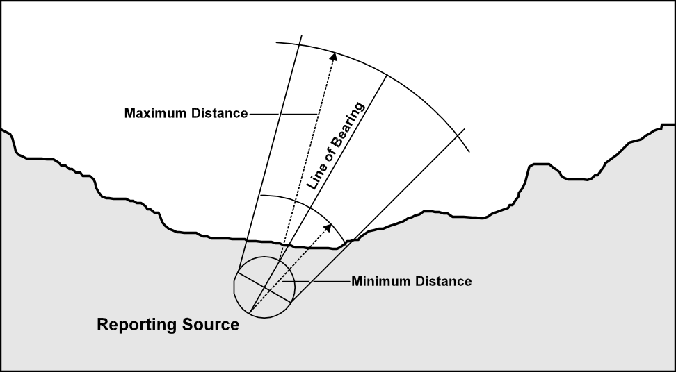

Figure I-12 Step 5: Plotting maximum and minimum arcs

I.5.1.6 Enclose the resulting area in a rectangle as shown in Figure I-13. Multiply the rectangle’s length and width by the appropriate safety factor (1.1 for the first search) and draw a second, larger rectangle around the first. This will be the search area.

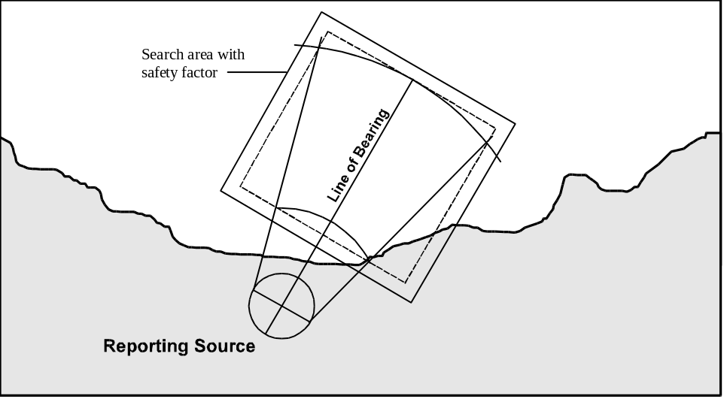

Figure I-13 Step 6: Enclosing the search area, including the safety factor

I.5.1.7 Check with local military and civilian authorities for the presence of operations, including possible fireworks displays. If the position of the sighting plots within a warning or restricted area, contact the controlling authority for possible correlation with activities in that area.
Caution: Although these procedures are designed to produce reasonably conservative results, search planners should not hesitate to expand the size of the search area if they feel it is too small or they have other reasons to believe the plotted area may have a less than 50% chance of containing the flare’s origin.

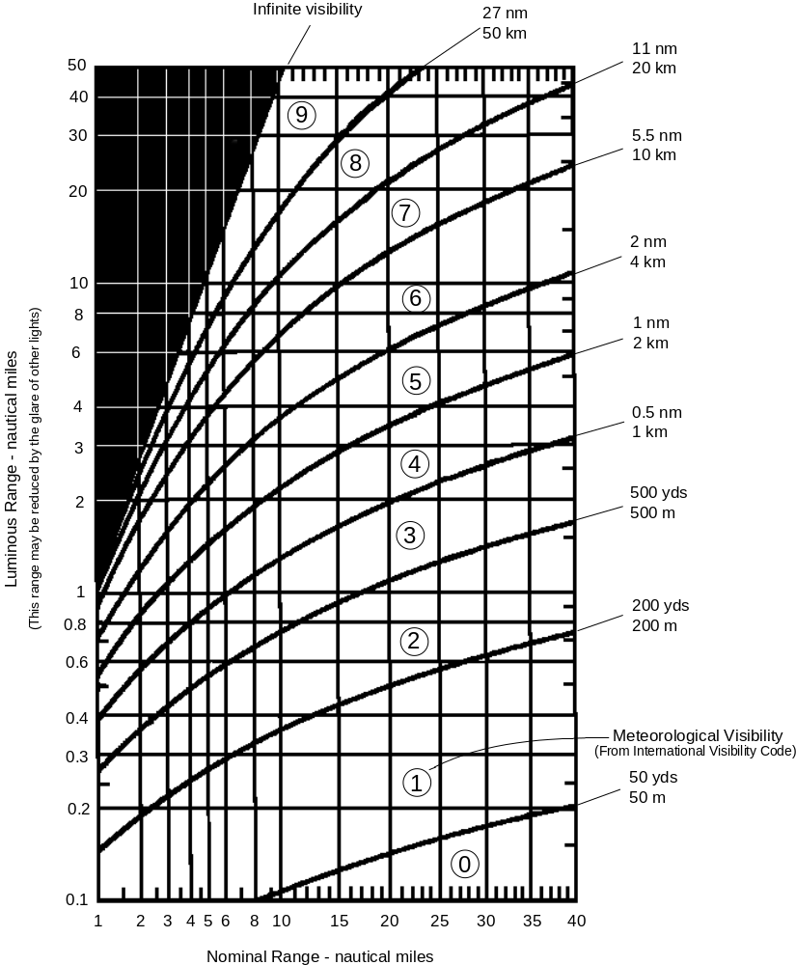

Figure I-14 Luminous Range Diagram (The American Practical Navigator, Bowditch, 1995)

I.5.2 Multiple Reporting Sources
When two or more reliable reporting sources provide good lines of bearing with good crossing angles, determining datum can be accomplished as in Figure I-15. For multiple report cases, determine which three reports are best and use these three reports to complete minimum and maximum calculations. Any time multiple reports are received, even from approximately the same location, the possibility of multiple flares must be considered.

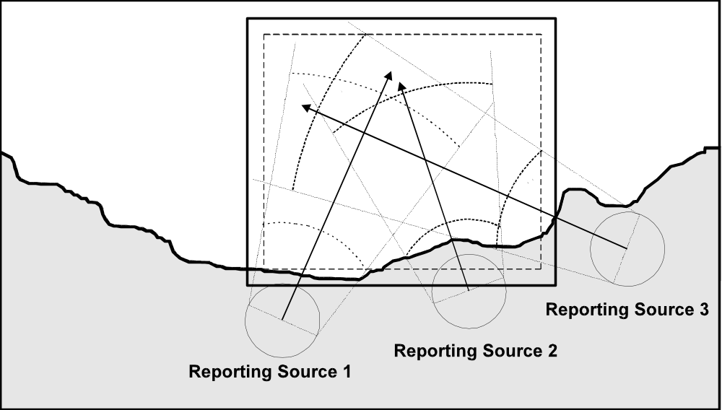

Figure I-15 Reporting sources with different positions

I.5.2.1 Reporting Sources have approximately the same position: Plot each individual reporting source’s estimated range and bearing to the flare, properly accounting for the uncertainties in the reporting source’s position, bearing estimate and vertical angle estimate. Once all reports are plotted, draw a rectangle that includes all of them, or at least all those that appear to be in reasonable agreement, and expand it by the appropriate safety factor.

I.5.2.2 Reporting Sources have significantly different positions: In this case if all reporting sources saw the same flare, there is a good chance of obtaining a reasonably accurate location for the flare by means of cross bearings. Again, plot each individual report as if it was a single report. Draw a rectangle that includes all of the points where bearing error lines cross and expand it by the appropriate safety factor. To be more conservative, include all the distance uncertainties as well, as shown in Figure I-15.

I.5.3 Search Planning
After establishing a datum area using the procedures outlined above, it will be necessary to plan a search based on this datum. If the difference between the time of the sighting and the SRU’s time of arrival on-scene is short, and the search object’s drift is likely to be slow, then the datum area may also be used as the search area. The search planner may then proceed with the remainder of the search planning and execution process. However, in areas of high drift rates or when there will be a significant delay in the SRU’s arrival on-scene, the search planner may need to compute a new datum area for the SRU’s projected arrival time which accounts for search object drift.

Report taken by: ________________________________________________ Date: ______________

FLARE SIGHTING CHECKSHEET
(page 1 of 4)

OBTAIN INFORMATION ABOUT THE REPORTING SOURCE
Name | First: |  |  |  |  |  |  |  |  |  |  |  |  |  | Last:
Position | Latitude: |  |  |  |  |  |  |  |  |  |  |  |  |  |  |  |  |  |  |  | Longitude:
 | Bearing and range from prominent landmark: |  |  |  |  |  |  |  |  |  |  |  |  |  |  |  |  |  |  |  |  |  |  |  |  |  |  |  |  |  |  |  |  |  | Deg & dist
 | Street
 | address:
 | Position uncertainty: +/- |  |  |  |  |  |  |  |  |  |  |  |  |  |  |  |  |  |  |  |  |  |  |  |  |  |  |  |  | nm
Height of eye | Height of reporting source, from sea level: |  |  |  |  |  |  |  |  |  |  |  |  |  |  |  |  |  |  |  |  |  |  |  |  |  |  |  |  |  |  | ft
 | If the reporting source is in a building, floor number:
Phone number | Current location:
 | Home or work:
OBTAIN INFORMATION ABOUT THE FLARE CHARACTERISTICS
Color | (Circle any that apply) RED AMBER WHITE GREEN OTHER:
Number of Flares | Number observed: |  |  |  |  |  |  |  |  |  |  |  |  |  |  |  |  |  | Time of sighting:
Time and Duration | Interval between flares: |  |  |  |  |  |  |  |  |  |  |  |  |  |  |  |  |  |  |  |  |  |  | Duration of burn:
Trajectory |  | Rise only |  |  |  |  |  |  | Fall only |  |  |  |  |  |  |  |  |  |  |  |  |  | Steady (no rise or fall)
 |  | Rapid rise and fall |  |  |  |  |  |  |  |  |  |  |  |  |  |  | Rapid rise and slow descent
Origin | Observed: yes / no |  |  |  |  |  |  |  |  |  | Near horizon |  |  |  |  |  |  |  |  |  |  |  |  |  |  | Between source and horizon
 | Flare origin: |  |  |  |  |  |  | Surface |  |  |  |  |  |  |  |  | Air |  |  |  |  |  |  |  |  |  |  | Other:
Type | (Based on above information)  PARACHUTE METEOR HANDHELD OTHER:

FLARE SIGHTING CHECKSHEET
(page 2 of 4)

DETERMINE ANGLE OF OBSERVATION AND POSITION
Angle of Observation | How determined:
 | If determined by Fist Method: Fractions of a fist(s):
 | Check one: |  |  |  |  |  | Angle below the horizon
 |  |  |  |  |  |  | Angle above horizon
 |  |  |  |  |  |  | Angle measured from flare origin to apex
 |  |  |  |  |  |  | Steady, no angle of elevation observed
 | Degrees: |  |  |  |  |  | Not more than: |  |  |  |  |  |  |  | deg |  |  |  |  | Not less than: |  |  |  |  |  |  |  |  |  | deg
Bearing from | How determined:
Observer | If determined by clock method: Bearing at |  |  |  |  |  |  |  |  |  |  |  |  |  |  |  |  |  |  |  | o’clock
 | Is the reporting source (or building that the reporting source is located in) perpendicular to the shoreline? yes / no
 | If no, what is the orientation of the location to the shore line? |  |  |  |  |  |  |  |  |  |  |  |  |  |  |  |  |  |  |  |  |  |  |  | deg.
 | Direction by: prominent landmark, street direction, moon, other
 | Degrees: |  |  |  |  |  |  |  |  |  |  | Uncertainty: + / - |  |  |  |  |  |  |  |  |  |  |  | degrees
Obstruction | List any obstructions in the line of sight of the reporting source.
 | Obstruction |  |  |  |  |  | in front of |  |  |  |  | behind flare ? |  |  |  |  |  | Obstruction height: |  |  |  |  |  |  |  |  |  |  | ft
On-Scene weather | Wind: |  |  |  |  | / |  |  |  |  | Seas: |  |  |  |  |  | / |  |  |  |  | Visibility: |  |  |  |  |  |  | /
Vessels/ Aircraft | Were any vessels or aircraft observed in the area? yes / no
Vessels/ Aircraft | If yes, description:
FLARE SIGHTING CHECKSHEET
(page 3 of 4)

OBTAIN CLEAR MENTAL PICTURE OF WHAT THE REPORTING SOURCE OBSERVED
Draw sketch here.
Angle above Horizon  HORIZON  Angle below Horizon |  | 1 fist  ¾  ½  ¼ |  | -------------------------------------  -------------------------------------  -------------------------------------  -------------------------------------
 |  | ¼  ½  ¾  1 fist |  | -------------------------------------  -------------------------------------  -------------------------------------  -------------------------------------
AMPLIFYING INFORMATION
Reporting Source on a Vessel | Will the reporting source respond to the sighting? yes / no
Reporting Source on a Vessel | If yes, expected time of arrival on scene:
Reporting Source on a Vessel | Intended action by the reporting source:
Reporting Source on Land | Will the reporting source remain on scene or on the phone? yes / no
Reporting Source on Land | If no, how can the reporting source by re-contacted?
Reporting Source on Land | Intended action by the reporting source:
Additional information
OBTAIN INFORMATION FROM MILITARY AND CIVILIAN AUTHORITIES
Determine if the flare sighting corresponds to any of the following:
Other flare sightings: |  |  | yes / no |  | Known SAR cases: |  |  |  | yes / no
Known Exercises in progress: |  |  | yes / no |  | Known Overdues: |  |  |  | yes / no
Known fireworks display: |  |  | yes / no
FLARE SIGHTING CHECKSHEET
(page 4 of 4)

ACTION TAKEN BY COAST GUARD
Distance | Distance from reporting source determined to be:
Distance | Minimum: |  | nm |  |  |  | Maximum: |  |  | nm |  |  | Uncertainty: + / - |  |  |  |  | nm
Distance | Bearing: |  |  |  |  |  |  |  |  |  |  |  | Uncertainty: + / - |  |  |  |  | deg
SAR Phase | Evaluate emergency SAR phase: DISTRESS ALERT UNCERTAINTY
UMIB | Issue UMIB: yes / no |  |  |  |  | Time issued: |  |  |  |  |  |  |  | Time cancelled
Launch Sorties | UNIT |  |  | STATION |  |  |  | ETA |  |  |  |  |  |  | ACTION
Other Assistance
Intentions
First Light Search | First light search planned: yes / no (Required for RED/ORANGE flares if there is insufficient information to either close or suspend).
First Light Search | Additional information:
ACTSUS | ACTSUS approved: yes / no

Table I-2a Angle of Observation Above the Horizon; Minimum Distance to the Flare (nm)
Reporting  Source  Height ft | 0.50 ⁰ | 1.00 ⁰ | 1.50 ⁰ | 2.00 ⁰ | 2.50 ⁰ | 3.00 ⁰ | 3.50 ⁰ | 4.00 ⁰ | 5.00 ⁰ | 6.00 ⁰ | 7.00 ⁰ | 8.00 ⁰ | 10.00 ⁰ | 12.00 ⁰ | 14.00 ⁰ | 16.00 ⁰
10 | 4.68 | 2.35 | 1.55 | 1.16 | 0.92 | 0.77 | 0.65 | 0.57 | 0.46 | 0.38 | 0.32 | 0.28 | 0.23 | 0.19 | 0.16 | 0.14
20 | 4.71 | 2.31 | 1.51 | 1.12 | 0.89 | 0.74 | 0.63 | 0.55 | 0.44 | 0.36 | 0.31 | 0.27 | 0.22 | 0.18 | 0.15 | 0.13
30 | 4.69 | 2.25 | 1.46 | 1.08 | 0.86 | 0.71 | 0.61 | 0.53 | 0.42 | 0.35 | 0.30 | 0.26 | 0.21 | 0.17 | 0.15 | 0.13
40 | 4.64 | 2.18 | 1.41 | 1.04 | 0.83 | 0.68 | 0.58 | 0.51 | 0.40 | 0.33 | 0.29 | 0.25 | 0.20 | 0.16 | 0.14 | 0.12
50 | 4.57 | 2.11 | 1.36 | 1.00 | 0.79 | 0.65 | 0.56 | 0.49 | 0.39 | 0.32 | 0.27 | 0.24 | 0.19 | 0.16 | 0.13 | 0.12
60 | 4.47 | 2.03 | 1.30 | 0.96 | 0.76 | 0.62 | 0.53 | 0.46 | 0.37 | 0.30 | 0.26 | 0.23 | 0.18 | 0.15 | 0.13 | 0.11
70 | 4.37 | 1.95 | 1.24 | 0.91 | 0.72 | 0.59 | 0.50 | 0.44 | 0.35 | 0.29 | 0.25 | 0.21 | 0.17 | 0.14 | 0.12 | 0.10
80 | 4.25 | 1.87 | 1.19 | 0.87 | 0.68 | 0.56 | 0.48 | 0.42 | 0.33 | 0.27 | 0.23 | 0.20 | 0.16 | 0.13 | 0.11 | 0.10
90 | 4.12 | 1.78 | 1.12 | 0.82 | 0.64 | 0.53 | 0.45 | 0.39 | 0.31 | 0.26 | 0.22 | 0.19 | 0.15 | 0.13 | 0.11 | 0.09
100 | 3.97 | 1.69 | 1.06 | 0.77 | 0.61 | 0.50 | 0.42 | 0.37 | 0.29 | 0.24 | 0.21 | 0.18 | 0.14 | 0.12 | 0.10 | 0.09
110 | 3.81 | 1.59 | 1.00 | 0.72 | 0.57 | 0.47 | 0.40 | 0.35 | 0.27 | 0.23 | 0.19 | 0.17 | 0.13 | 0.11 | 0.09 | 0.08
120 | 3.64 | 1.50 | 0.93 | 0.68 | 0.53 | 0.44 | 0.37 | 0.32 | 0.25 | 0.21 | 0.18 | 0.16 | 0.12 | 0.10 | 0.09 | 0.08
130 | 3.46 | 1.40 | 0.87 | 0.63 | 0.49 | 0.40 | 0.34 | 0.30 | 0.24 | 0.19 | 0.17 | 0.14 | 0.11 | 0.09 | 0.08 | 0.07
140 | 3.26 | 1.29 | 0.80 | 0.58 | 0.45 | 0.37 | 0.31 | 0.27 | 0.22 | 0.18 | 0.15 | 0.13 | 0.10 | 0.09 | 0.07 | 0.06
150 | 3.05 | 1.19 | 0.73 | 0.53 | 0.41 | 0.34 | 0.29 | 0.25 | 0.20 | 0.16 | 0.14 | 0.12 | 0.10 | 0.08 | 0.07 | 0.06
160 | 2.83 | 1.08 | 0.66 | 0.48 | 0.37 | 0.30 | 0.26 | 0.22 | 0.18 | 0.15 | 0.12 | 0.11 | 0.09 | 0.07 | 0.06 | 0.05
170 | 2.59 | 0.97 | 0.59 | 0.43 | 0.33 | 0.27 | 0.23 | 0.20 | 0.16 | 0.13 | 0.11 | 0.10 | 0.08 | 0.06 | 0.05 | 0.05
180 | 2.34 | 0.86 | 0.52 | 0.37 | 0.29 | 0.24 | 0.20 | 0.18 | 0.14 | 0.11 | 0.10 | 0.08 | 0.07 | 0.06 | 0.05 | 0.04
190 | 2.07 | 0.74 | 0.45 | 0.32 | 0.25 | 0.20 | 0.17 | 0.15 | 0.12 | 0.10 | 0.08 | 0.07 | 0.06 | 0.05 | 0.04 | 0.03
200 | 1.78 | 0.62 | 0.38 | 0.27 | 0.21 | 0.17 | 0.14 | 0.13 | 0.10 | 0.08 | 0.07 | 0.06 | 0.05 | 0.04 | 0.03 | 0.03
220 | 1.15 | 0.38 | 0.23 | 0.16 | 0.13 | 0.10 | 0.09 | 0.08 | 0.06 | 0.05 | 0.04 | 0.04 | 0.03 | 0.02 | 0.02 | 0.02
240 | 0.41 | 0.13 | 0.08 | 0.05 | 0.04 | 0.03 | 0.03 | 0.03 | 0.02 | 0.02 | 0.01 | 0.01 | 0.01 | 0.01 | 0.01 | 0.01
260 | 0.43 | 0.13 | 0.08 | 0.05 | 0.04 | 0.03 | 0.03 | 0.03 | 0.02 | 0.02 | 0.01 | 0.01 | 0.01 | 0.01 | 0.01 | 0.01
280 | 0.45 | 0.13 | 0.08 | 0.06 | 0.04 | 0.03 | 0.03 | 0.03 | 0.02 | 0.02 | 0.01 | 0.01 | 0.01 | 0.01 | 0.01 | 0.01
300 | 0.48 | 0.14 | 0.08 | 0.06 | 0.04 | 0.03 | 0.03 | 0.03 | 0.02 | 0.02 | 0.01 | 0.01 | 0.01 | 0.01 | 0.01 | 0.01
320 | 0.50 | 0.14 | 0.08 | 0.06 | 0.04 | 0.04 | 0.03 | 0.03 | 0.02 | 0.02 | 0.01 | 0.01 | 0.01 | 0.01 | 0.01 | 0.01
340 | 0.53 | 0.14 | 0.08 | 0.06 | 0.04 | 0.04 | 0.03 | 0.03 | 0.02 | 0.02 | 0.01 | 0.01 | 0.01 | 0.01 | 0.01 | 0.01
360 | 0.56 | 0.14 | 0.08 | 0.06 | 0.04 | 0.04 | 0.03 | 0.03 | 0.02 | 0.02 | 0.01 | 0.01 | 0.01 | 0.01 | 0.01 | 0.01
380 | 0.59 | 0.14 | 0.08 | 0.06 | 0.04 | 0.04 | 0.03 | 0.03 | 0.02 | 0.02 | 0.01 | 0.01 | 0.01 | 0.01 | 0.01 | 0.01
400 | 0.62 | 0.15 | 0.08 | 0.06 | 0.04 | 0.04 | 0.03 | 0.03 | 0.02 | 0.02 | 0.01 | 0.01 | 0.01 | 0.01 | 0.01 | 0.01
420 | 0.66 | 0.15 | 0.08 | 0.06 | 0.04 | 0.04 | 0.03 | 0.03 | 0.02 | 0.02 | 0.01 | 0.01 | 0.01 | 0.01 | 0.01 | 0.01
440 | 0.70 | 0.15 | 0.08 | 0.06 | 0.04 | 0.04 | 0.03 | 0.03 | 0.02 | 0.02 | 0.01 | 0.01 | 0.01 | 0.01 | 0.01 | 0.01
460 | 0.75 | 0.15 | 0.08 | 0.06 | 0.04 | 0.04 | 0.03 | 0.03 | 0.02 | 0.02 | 0.01 | 0.01 | 0.01 | 0.01 | 0.01 | 0.01
480 | 0.80 | 0.15 | 0.08 | 0.06 | 0.04 | 0.04 | 0.03 | 0.03 | 0.02 | 0.02 | 0.01 | 0.01 | 0.01 | 0.01 | 0.01 | 0.01
500 | 0.85 | 0.16 | 0.09 | 0.06 | 0.04 | 0.04 | 0.03 | 0.03 | 0.02 | 0.02 | 0.01 | 0.01 | 0.01 | 0.01 | 0.01 | 0.01
520 | 0.91 | 0.16 | 0.09 | 0.06 | 0.04 | 0.04 | 0.03 | 0.03 | 0.02 | 0.02 | 0.01 | 0.01 | 0.01 | 0.01 | 0.01 | 0.01
540 | 0.98 | 0.16 | 0.09 | 0.06 | 0.05 | 0.04 | 0.03 | 0.03 | 0.02 | 0.02 | 0.01 | 0.01 | 0.01 | 0.01 | 0.01 | 0.01
560 | 1.05 | 0.16 | 0.09 | 0.06 | 0.05 | 0.04 | 0.03 | 0.03 | 0.02 | 0.02 | 0.01 | 0.01 | 0.01 | 0.01 | 0.01 | 0.01
580 | 1.14 | 0.16 | 0.09 | 0.06 | 0.05 | 0.04 | 0.03 | 0.03 | 0.02 | 0.02 | 0.01 | 0.01 | 0.01 | 0.01 | 0.01 | 0.01
600 | 1.24 | 0.17 | 0.09 | 0.06 | 0.05 | 0.04 | 0.03 | 0.03 | 0.02 | 0.02 | 0.01 | 0.01 | 0.01 | 0.01 | 0.01 | 0.01
620 | 1.35 | 0.17 | 0.09 | 0.06 | 0.05 | 0.04 | 0.03 | 0.03 | 0.02 | 0.02 | 0.01 | 0.01 | 0.01 | 0.01 | 0.01 | 0.01
640 | 1.47 | 0.17 | 0.09 | 0.06 | 0.05 | 0.04 | 0.03 | 0.03 | 0.02 | 0.02 | 0.01 | 0.01 | 0.01 | 0.01 | 0.01 | 0.01
660 | 1.62 | 0.17 | 0.09 | 0.06 | 0.05 | 0.04 | 0.03 | 0.03 | 0.02 | 0.02 | 0.01 | 0.01 | 0.01 | 0.01 | 0.01 | 0.01
680 | 1.78 | 0.17 | 0.09 | 0.06 | 0.05 | 0.04 | 0.03 | 0.03 | 0.02 | 0.02 | 0.01 | 0.01 | 0.01 | 0.01 | 0.01 | 0.01
700 | 1.98 | 0.18 | 0.09 | 0.06 | 0.05 | 0.04 | 0.03 | 0.03 | 0.02 | 0.02 | 0.01 | 0.01 | 0.01 | 0.01 | 0.01 | 0.01
720 | 2.20 | 0.18 | 0.09 | 0.06 | 0.05 | 0.04 | 0.03 | 0.03 | 0.02 | 0.02 | 0.01 | 0.01 | 0.01 | 0.01 | 0.01 | 0.01
740 | 2.45 | 0.18 | 0.09 | 0.06 | 0.05 | 0.04 | 0.03 | 0.03 | 0.02 | 0.02 | 0.01 | 0.01 | 0.01 | 0.01 | 0.01 | 0.01
760 | 2.74 | 0.18 | 0.09 | 0.06 | 0.05 | 0.04 | 0.03 | 0.03 | 0.02 | 0.02 | 0.01 | 0.01 | 0.01 | 0.01 | 0.01 | 0.01
780 | 3.07 | 0.19 | 0.09 | 0.06 | 0.05 | 0.04 | 0.03 | 0.03 | 0.02 | 0.02 | 0.01 | 0.01 | 0.01 | 0.01 | 0.01 | 0.01
800 | 3.44 | 0.19 | 0.09 | 0.06 | 0.05 | 0.04 | 0.03 | 0.03 | 0.02 | 0.02 | 0.01 | 0.01 | 0.01 | 0.01 | 0.01 | 0.01
820 | 3.84 | 0.19 | 0.09 | 0.06 | 0.05 | 0.04 | 0.03 | 0.03 | 0.02 | 0.02 | 0.01 | 0.01 | 0.01 | 0.01 | 0.01 | 0.01
840 | 4.27 | 0.19 | 0.10 | 0.06 | 0.05 | 0.04 | 0.03 | 0.03 | 0.02 | 0.02 | 0.01 | 0.01 | 0.01 | 0.01 | 0.01 | 0.01
860 | 4.74 | 0.20 | 0.10 | 0.06 | 0.05 | 0.04 | 0.03 | 0.03 | 0.02 | 0.02 | 0.01 | 0.01 | 0.01 | 0.01 | 0.01 | 0.01
880 | 5.24 | 0.20 | 0.10 | 0.06 | 0.05 | 0.04 | 0.03 | 0.03 | 0.02 | 0.02 | 0.01 | 0.01 | 0.01 | 0.01 | 0.01 | 0.01
900 | 5.76 | 0.20 | 0.10 | 0.06 | 0.05 | 0.04 | 0.03 | 0.03 | 0.02 | 0.02 | 0.01 | 0.01 | 0.01 | 0.01 | 0.01 | 0.01
920 | 6.29 | 0.20 | 0.10 | 0.06 | 0.05 | 0.04 | 0.03 | 0.03 | 0.02 | 0.02 | 0.01 | 0.01 | 0.01 | 0.01 | 0.01 | 0.01
940 | 6.85 | 0.21 | 0.10 | 0.06 | 0.05 | 0.04 | 0.03 | 0.03 | 0.02 | 0.02 | 0.01 | 0.01 | 0.01 | 0.01 | 0.01 | 0.01
960 | 7.41 | 0.21 | 0.10 | 0.06 | 0.05 | 0.04 | 0.03 | 0.03 | 0.02 | 0.02 | 0.01 | 0.01 | 0.01 | 0.01 | 0.01 | 0.01
980 | 7.98 | 0.21 | 0.10 | 0.07 | 0.05 | 0.04 | 0.03 | 0.03 | 0.02 | 0.02 | 0.01 | 0.01 | 0.01 | 0.01 | 0.01 | 0.01
1000 | 8.56 | 0.21 | 0.10 | 0.07 | 0.05 | 0.04 | 0.03 | 0.03 | 0.02 | 0.02 | 0.01 | 0.01 | 0.01 | 0.01 | 0.01 | 0.01

Table I-2b Angle of Observation Above the Horizon; Maximum Distance to the Flare
Reporting | 0.50 ⁰ | 1.00 ⁰ | 1.50 ⁰ | 2.00 ⁰ | 2.50 ⁰ | 3.00 ⁰ | 3.50 ⁰ | 4.00 ⁰ | 5.00 ⁰ | 6.00 ⁰ | 7.00 ⁰ | 8.00 ⁰ | 10.00 ⁰ | 12.00 ⁰ | 14.00 ⁰ | 16.00 ⁰
Source
Height ft
10 | 18.69 | 10.84 | 7.44 | 5.63 | 4.52 | 3.77 | 3.23 | 2.82 | 2.25 | 1.87 | 1.60 | 1.40 | 1.12 | 0.92 | 0.79 | 0.68
20 | 19.16 | 10.98 | 7.49 | 5.65 | 4.52 | 3.76 | 3.22 | 2.81 | 2.25 | 1.87 | 1.60 | 1.39 | 1.11 | 0.92 | 0.78 | 0.68
30 | 19.50 | 11.08 | 7.52 | 5.65 | 4.51 | 3.75 | 3.21 | 2.80 | 2.23 | 1.86 | 1.59 | 1.38 | 1.10 | 0.91 | 0.78 | 0.68
40 | 19.77 | 11.14 | 7.53 | 5.65 | 4.50 | 3.74 | 3.20 | 2.79 | 2.22 | 1.85 | 1.58 | 1.37 | 1.09 | 0.91 | 0.77 | 0.67
50 | 20.01 | 11.19 | 7.54 | 5.64 | 4.49 | 3.73 | 3.18 | 2.78 | 2.21 | 1.83 | 1.57 | 1.37 | 1.09 | 0.90 | 0.77 | 0.66
60 | 20.22 | 11.23 | 7.53 | 5.62 | 4.47 | 3.71 | 3.17 | 2.76 | 2.20 | 1.82 | 1.55 | 1.36 | 1.08 | 0.89 | 0.76 | 0.66
70 | 20.40 | 11.26 | 7.53 | 5.61 | 4.45 | 3.69 | 3.15 | 2.74 | 2.18 | 1.81 | 1.54 | 1.35 | 1.07 | 0.89 | 0.75 | 0.65
80 | 20.57 | 11.28 | 7.51 | 5.59 | 4.43 | 3.67 | 3.13 | 2.73 | 2.17 | 1.80 | 1.53 | 1.34 | 1.06 | 0.88 | 0.75 | 0.65
90 | 20.73 | 11.29 | 7.50 | 5.57 | 4.41 | 3.65 | 3.11 | 2.71 | 2.15 | 1.78 | 1.52 | 1.33 | 1.05 | 0.87 | 0.74 | 0.64
100 | 20.87 | 11.30 | 7.48 | 5.54 | 4.39 | 3.63 | 3.09 | 2.69 | 2.14 | 1.77 | 1.51 | 1.31 | 1.04 | 0.86 | 0.73 | 0.64
110 | 21.00 | 11.31 | 7.46 | 5.52 | 4.37 | 3.61 | 3.07 | 2.67 | 2.12 | 1.76 | 1.50 | 1.30 | 1.04 | 0.86 | 0.73 | 0.63
120 | 21.12 | 11.30 | 7.44 | 5.49 | 4.34 | 3.59 | 3.05 | 2.65 | 2.10 | 1.74 | 1.49 | 1.29 | 1.03 | 0.85 | 0.72 | 0.63
130 | 21.23 | 11.30 | 7.41 | 5.47 | 4.32 | 3.56 | 3.03 | 2.64 | 2.09 | 1.73 | 1.47 | 1.28 | 1.02 | 0.84 | 0.72 | 0.62
140 | 21.33 | 11.29 | 7.39 | 5.44 | 4.29 | 3.54 | 3.01 | 2.62 | 2.07 | 1.71 | 1.46 | 1.27 | 1.01 | 0.83 | 0.71 | 0.62
150 | 21.43 | 11.28 | 7.36 | 5.41 | 4.27 | 3.52 | 2.99 | 2.60 | 2.06 | 1.70 | 1.45 | 1.26 | 1.00 | 0.83 | 0.70 | 0.61
160 | 21.52 | 11.27 | 7.33 | 5.38 | 4.24 | 3.49 | 2.97 | 2.58 | 2.04 | 1.69 | 1.44 | 1.25 | 0.99 | 0.82 | 0.70 | 0.61
170 | 21.61 | 11.25 | 7.30 | 5.35 | 4.21 | 3.47 | 2.94 | 2.56 | 2.02 | 1.67 | 1.42 | 1.24 | 0.98 | 0.81 | 0.69 | 0.60
180 | 21.69 | 11.23 | 7.26 | 5.32 | 4.18 | 3.44 | 2.92 | 2.54 | 2.01 | 1.66 | 1.41 | 1.23 | 0.97 | 0.81 | 0.68 | 0.59
190 | 21.77 | 11.21 | 7.23 | 5.29 | 4.15 | 3.42 | 2.90 | 2.52 | 1.99 | 1.64 | 1.40 | 1.22 | 0.97 | 0.80 | 0.68 | 0.59
200 | 21.84 | 11.18 | 7.20 | 5.25 | 4.12 | 3.39 | 2.88 | 2.50 | 1.97 | 1.63 | 1.39 | 1.21 | 0.96 | 0.79 | 0.67 | 0.58
220 | 21.97 | 11.13 | 7.12 | 5.19 | 4.06 | 3.34 | 2.83 | 2.45 | 1.94 | 1.60 | 1.36 | 1.18 | 0.94 | 0.78 | 0.66 | 0.57
240 | 22.09 | 11.06 | 7.04 | 5.11 | 4.00 | 3.28 | 2.78 | 2.41 | 1.90 | 1.57 | 1.34 | 1.16 | 0.92 | 0.76 | 0.65 | 0.56
260 | 22.19 | 10.99 | 6.96 | 5.04 | 3.94 | 3.23 | 2.73 | 2.37 | 1.87 | 1.54 | 1.31 | 1.14 | 0.90 | 0.75 | 0.63 | 0.55
280 | 22.28 | 10.91 | 6.87 | 4.97 | 3.88 | 3.17 | 2.68 | 2.33 | 1.83 | 1.51 | 1.29 | 1.12 | 0.88 | 0.73 | 0.62 | 0.54
300 | 22.35 | 10.83 | 6.79 | 4.89 | 3.81 | 3.12 | 2.64 | 2.28 | 1.80 | 1.48 | 1.26 | 1.09 | 0.87 | 0.71 | 0.61 | 0.53
320 | 22.42 | 10.73 | 6.69 | 4.81 | 3.74 | 3.06 | 2.58 | 2.24 | 1.76 | 1.45 | 1.23 | 1.07 | 0.85 | 0.70 | 0.59 | 0.52
340 | 22.47 | 10.64 | 6.60 | 4.73 | 3.68 | 3.00 | 2.53 | 2.19 | 1.72 | 1.42 | 1.21 | 1.05 | 0.83 | 0.68 | 0.58 | 0.50
360 | 22.52 | 10.53 | 6.50 | 4.65 | 3.61 | 2.94 | 2.48 | 2.15 | 1.69 | 1.39 | 1.18 | 1.03 | 0.81 | 0.67 | 0.57 | 0.49
380 | 22.56 | 10.42 | 6.40 | 4.56 | 3.54 | 2.88 | 2.43 | 2.10 | 1.65 | 1.36 | 1.15 | 1.00 | 0.79 | 0.65 | 0.55 | 0.48
400 | 22.58 | 10.30 | 6.29 | 4.48 | 3.47 | 2.82 | 2.38 | 2.06 | 1.61 | 1.33 | 1.13 | 0.98 | 0.77 | 0.64 | 0.54 | 0.47
420 | 22.60 | 10.18 | 6.18 | 4.39 | 3.39 | 2.76 | 2.33 | 2.01 | 1.58 | 1.30 | 1.10 | 0.96 | 0.75 | 0.62 | 0.53 | 0.46
440 | 22.61 | 10.06 | 6.07 | 4.30 | 3.32 | 2.70 | 2.27 | 1.96 | 1.54 | 1.27 | 1.07 | 0.93 | 0.74 | 0.61 | 0.52 | 0.45
460 | 22.61 | 9.92 | 5.96 | 4.21 | 3.25 | 2.64 | 2.22 | 1.92 | 1.50 | 1.23 | 1.05 | 0.91 | 0.72 | 0.59 | 0.50 | 0.44
480 | 22.60 | 9.78 | 5.85 | 4.12 | 3.17 | 2.57 | 2.17 | 1.87 | 1.46 | 1.20 | 1.02 | 0.89 | 0.70 | 0.58 | 0.49 | 0.42
500 | 22.59 | 9.64 | 5.73 | 4.03 | 3.10 | 2.51 | 2.11 | 1.82 | 1.43 | 1.17 | 0.99 | 0.86 | 0.68 | 0.56 | 0.48 | 0.41
520 | 22.56 | 9.49 | 5.61 | 3.93 | 3.02 | 2.45 | 2.06 | 1.77 | 1.39 | 1.14 | 0.97 | 0.84 | 0.66 | 0.54 | 0.46 | 0.40
540 | 22.53 | 9.34 | 5.48 | 3.84 | 2.94 | 2.38 | 2.00 | 1.72 | 1.35 | 1.11 | 0.94 | 0.81 | 0.64 | 0.53 | 0.45 | 0.39
560 | 22.49 | 9.18 | 5.36 | 3.74 | 2.86 | 2.32 | 1.95 | 1.68 | 1.31 | 1.08 | 0.91 | 0.79 | 0.62 | 0.51 | 0.44 | 0.38
580 | 22.44 | 9.01 | 5.23 | 3.64 | 2.79 | 2.25 | 1.89 | 1.63 | 1.27 | 1.04 | 0.88 | 0.77 | 0.60 | 0.50 | 0.42 | 0.37
600 | 22.39 | 8.84 | 5.10 | 3.54 | 2.71 | 2.19 | 1.83 | 1.58 | 1.23 | 1.01 | 0.86 | 0.74 | 0.59 | 0.48 | 0.41 | 0.35
620 | 22.32 | 8.66 | 4.97 | 3.44 | 2.63 | 2.12 | 1.78 | 1.53 | 1.19 | 0.98 | 0.83 | 0.72 | 0.57 | 0.47 | 0.40 | 0.34
640 | 22.25 | 8.48 | 4.83 | 3.34 | 2.54 | 2.05 | 1.72 | 1.48 | 1.15 | 0.95 | 0.80 | 0.69 | 0.55 | 0.45 | 0.38 | 0.33
660 | 22.17 | 8.29 | 4.69 | 3.24 | 2.46 | 1.99 | 1.66 | 1.43 | 1.11 | 0.91 | 0.77 | 0.67 | 0.53 | 0.43 | 0.37 | 0.32
680 | 22.08 | 8.09 | 4.55 | 3.13 | 2.38 | 1.92 | 1.60 | 1.38 | 1.08 | 0.88 | 0.75 | 0.65 | 0.51 | 0.42 | 0.36 | 0.31
700 | 21.98 | 7.89 | 4.41 | 3.03 | 2.30 | 1.85 | 1.55 | 1.33 | 1.04 | 0.85 | 0.72 | 0.62 | 0.49 | 0.40 | 0.34 | 0.30
720 | 21.87 | 7.68 | 4.27 | 2.92 | 2.21 | 1.78 | 1.49 | 1.28 | 1.00 | 0.82 | 0.69 | 0.60 | 0.47 | 0.39 | 0.33 | 0.28
740 | 21.75 | 7.47 | 4.12 | 2.81 | 2.13 | 1.71 | 1.43 | 1.23 | 0.96 | 0.78 | 0.66 | 0.57 | 0.45 | 0.37 | 0.31 | 0.27
760 | 21.63 | 7.25 | 3.97 | 2.70 | 2.04 | 1.64 | 1.37 | 1.18 | 0.92 | 0.75 | 0.63 | 0.55 | 0.43 | 0.36 | 0.30 | 0.26
780 | 21.49 | 7.02 | 3.82 | 2.59 | 1.96 | 1.57 | 1.31 | 1.12 | 0.88 | 0.72 | 0.61 | 0.52 | 0.41 | 0.34 | 0.29 | 0.25
800 | 21.34 | 6.79 | 3.66 | 2.48 | 1.87 | 1.50 | 1.25 | 1.07 | 0.83 | 0.68 | 0.58 | 0.50 | 0.39 | 0.32 | 0.27 | 0.24
820 | 21.18 | 6.54 | 3.50 | 2.37 | 1.78 | 1.43 | 1.19 | 1.02 | 0.79 | 0.65 | 0.55 | 0.47 | 0.37 | 0.31 | 0.26 | 0.23
840 | 21.01 | 6.29 | 3.34 | 2.25 | 1.69 | 1.36 | 1.13 | 0.97 | 0.75 | 0.62 | 0.52 | 0.45 | 0.35 | 0.29 | 0.25 | 0.21
860 | 20.82 | 6.04 | 3.18 | 2.14 | 1.61 | 1.29 | 1.07 | 0.92 | 0.71 | 0.58 | 0.49 | 0.43 | 0.33 | 0.28 | 0.23 | 0.20
880 | 20.62 | 5.77 | 3.02 | 2.02 | 1.52 | 1.21 | 1.01 | 0.87 | 0.67 | 0.55 | 0.46 | 0.40 | 0.32 | 0.26 | 0.22 | 0.19
900 | 20.41 | 5.50 | 2.85 | 1.90 | 1.43 | 1.14 | 0.95 | 0.81 | 0.63 | 0.51 | 0.43 | 0.38 | 0.30 | 0.24 | 0.21 | 0.18
920 | 20.18 | 5.21 | 2.68 | 1.79 | 1.34 | 1.07 | 0.89 | 0.76 | 0.59 | 0.48 | 0.41 | 0.35 | 0.28 | 0.23 | 0.19 | 0.17
940 | 19.94 | 4.92 | 2.51 | 1.67 | 1.24 | 0.99 | 0.83 | 0.71 | 0.55 | 0.45 | 0.38 | 0.33 | 0.26 | 0.21 | 0.18 | 0.15
960 | 19.68 | 4.62 | 2.33 | 1.54 | 1.15 | 0.92 | 0.76 | 0.65 | 0.51 | 0.41 | 0.35 | 0.30 | 0.24 | 0.19 | 0.17 | 0.14
980 | 19.39 | 4.31 | 2.15 | 1.42 | 1.06 | 0.84 | 0.70 | 0.60 | 0.46 | 0.38 | 0.32 | 0.28 | 0.22 | 0.18 | 0.15 | 0.13
1000 | 19.09 | 3.99 | 1.97 | 1.30 | 0.97 | 0.77 | 0.64 | 0.55 | 0.42 | 0.35 | 0.29 | 0.25 | 0.20 | 0.16 | 0.14 | 0.12

Table I-3a Angle of Observation Below the Horizon; Minimum Distance to the Flare (nm)
Reporting | 0.50 ⁰ | 1.00 ⁰ | 1.50 ⁰ | 2.00 ⁰ | 2.50 ⁰ | 3.00 ⁰ | 3.50 ⁰ | 4.00 ⁰ | 5.00 ⁰ | 6.00 ⁰ | 7.00 ⁰ | 8.00 ⁰ | 10.00 ⁰ | 12.00 ⁰ | 14.00 ⁰ | 16.00 ⁰
Source
Height ft
10 | 0.17 | 0.09 | 0.06 | 0.05 | 0.04 | 0.03 | 0.03 | 0.02 | 0.02 | 0.02 | 0.01 | 0.01 | 0.01 | 0.01 | 0.01 | 0.01
20 | 0.16 | 0.09 | 0.06 | 0.05 | 0.04 | 0.03 | 0.03 | 0.02 | 0.02 | 0.02 | 0.01 | 0.01 | 0.01 | 0.01 | 0.01 | 0.01
30 | 0.16 | 0.09 | 0.06 | 0.04 | 0.04 | 0.03 | 0.03 | 0.02 | 0.02 | 0.02 | 0.01 | 0.01 | 0.01 | 0.01 | 0.01 | 0.01
40 | 0.15 | 0.08 | 0.06 | 0.04 | 0.04 | 0.03 | 0.03 | 0.02 | 0.02 | 0.02 | 0.01 | 0.01 | 0.01 | 0.01 | 0.01 | 0.01
50 | 0.15 | 0.08 | 0.06 | 0.04 | 0.04 | 0.03 | 0.03 | 0.02 | 0.02 | 0.02 | 0.01 | 0.01 | 0.01 | 0.01 | 0.01 | 0.01
60 | 0.15 | 0.08 | 0.06 | 0.04 | 0.04 | 0.03 | 0.03 | 0.02 | 0.02 | 0.02 | 0.01 | 0.01 | 0.01 | 0.01 | 0.01 | 0.01
70 | 0.15 | 0.08 | 0.06 | 0.04 | 0.04 | 0.03 | 0.03 | 0.02 | 0.02 | 0.02 | 0.01 | 0.01 | 0.01 | 0.01 | 0.01 | 0.01
80 | 0.14 | 0.08 | 0.06 | 0.04 | 0.04 | 0.03 | 0.03 | 0.02 | 0.02 | 0.02 | 0.01 | 0.01 | 0.01 | 0.01 | 0.01 | 0.01
90 | 0.14 | 0.08 | 0.06 | 0.04 | 0.04 | 0.03 | 0.03 | 0.02 | 0.02 | 0.02 | 0.01 | 0.01 | 0.01 | 0.01 | 0.01 | 0.01
100 | 0.14 | 0.08 | 0.06 | 0.04 | 0.04 | 0.03 | 0.03 | 0.02 | 0.02 | 0.02 | 0.01 | 0.01 | 0.01 | 0.01 | 0.01 | 0.01
110 | 0.14 | 0.08 | 0.06 | 0.04 | 0.04 | 0.03 | 0.03 | 0.02 | 0.02 | 0.02 | 0.01 | 0.01 | 0.01 | 0.01 | 0.01 | 0.01
120 | 0.14 | 0.08 | 0.06 | 0.04 | 0.03 | 0.03 | 0.03 | 0.02 | 0.02 | 0.02 | 0.01 | 0.01 | 0.01 | 0.01 | 0.01 | 0.01
130 | 0.13 | 0.08 | 0.06 | 0.04 | 0.03 | 0.03 | 0.03 | 0.02 | 0.02 | 0.02 | 0.01 | 0.01 | 0.01 | 0.01 | 0.01 | 0.01
140 | 0.13 | 0.08 | 0.06 | 0.04 | 0.03 | 0.03 | 0.03 | 0.02 | 0.02 | 0.02 | 0.01 | 0.01 | 0.01 | 0.01 | 0.01 | 0.01
150 | 0.13 | 0.08 | 0.05 | 0.04 | 0.03 | 0.03 | 0.03 | 0.02 | 0.02 | 0.02 | 0.01 | 0.01 | 0.01 | 0.01 | 0.01 | 0.01
160 | 0.13 | 0.08 | 0.05 | 0.04 | 0.03 | 0.03 | 0.03 | 0.02 | 0.02 | 0.02 | 0.01 | 0.01 | 0.01 | 0.01 | 0.01 | 0.01
170 | 0.13 | 0.08 | 0.05 | 0.04 | 0.03 | 0.03 | 0.03 | 0.02 | 0.02 | 0.02 | 0.01 | 0.01 | 0.01 | 0.01 | 0.01 | 0.01
180 | 0.13 | 0.08 | 0.05 | 0.04 | 0.03 | 0.03 | 0.03 | 0.02 | 0.02 | 0.02 | 0.01 | 0.01 | 0.01 | 0.01 | 0.01 | 0.01
190 | 0.13 | 0.08 | 0.05 | 0.04 | 0.03 | 0.03 | 0.03 | 0.02 | 0.02 | 0.02 | 0.01 | 0.01 | 0.01 | 0.01 | 0.01 | 0.01
200 | 0.13 | 0.08 | 0.05 | 0.04 | 0.03 | 0.03 | 0.03 | 0.02 | 0.02 | 0.02 | 0.01 | 0.01 | 0.01 | 0.01 | 0.01 | 0.01
220 | 0.12 | 0.07 | 0.05 | 0.04 | 0.03 | 0.03 | 0.03 | 0.02 | 0.02 | 0.01 | 0.01 | 0.01 | 0.01 | 0.01 | 0.01 | 0.01
240 | 0.12 | 0.07 | 0.05 | 0.04 | 0.03 | 0.03 | 0.02 | 0.02 | 0.02 | 0.01 | 0.01 | 0.01 | 0.01 | 0.01 | 0.01 | 0.01
260 | 0.12 | 0.07 | 0.05 | 0.04 | 0.03 | 0.03 | 0.02 | 0.02 | 0.02 | 0.01 | 0.01 | 0.01 | 0.01 | 0.01 | 0.01 | 0.01
280 | 0.36 | 0.22 | 0.16 | 0.12 | 0.10 | 0.09 | 0.07 | 0.07 | 0.05 | 0.04 | 0.04 | 0.03 | 0.03 | 0.02 | 0.02 | 0.02
300 | 0.59 | 0.36 | 0.26 | 0.20 | 0.17 | 0.14 | 0.12 | 0.11 | 0.09 | 0.07 | 0.06 | 0.06 | 0.05 | 0.04 | 0.03 | 0.03
320 | 0.81 | 0.50 | 0.36 | 0.28 | 0.23 | 0.20 | 0.17 | 0.15 | 0.12 | 0.10 | 0.09 | 0.08 | 0.06 | 0.05 | 0.05 | 0.04
340 | 1.04 | 0.64 | 0.47 | 0.36 | 0.30 | 0.25 | 0.22 | 0.20 | 0.16 | 0.13 | 0.12 | 0.10 | 0.08 | 0.07 | 0.06 | 0.05
360 | 1.26 | 0.78 | 0.57 | 0.44 | 0.37 | 0.31 | 0.27 | 0.24 | 0.19 | 0.16 | 0.14 | 0.12 | 0.10 | 0.08 | 0.07 | 0.06
380 | 1.47 | 0.92 | 0.67 | 0.52 | 0.43 | 0.37 | 0.32 | 0.28 | 0.23 | 0.19 | 0.17 | 0.15 | 0.12 | 0.10 | 0.08 | 0.07
400 | 1.68 | 1.05 | 0.76 | 0.60 | 0.50 | 0.42 | 0.37 | 0.32 | 0.26 | 0.22 | 0.19 | 0.17 | 0.14 | 0.11 | 0.10 | 0.08
420 | 1.89 | 1.18 | 0.86 | 0.68 | 0.56 | 0.48 | 0.41 | 0.37 | 0.30 | 0.25 | 0.22 | 0.19 | 0.15 | 0.13 | 0.11 | 0.10
440 | 2.10 | 1.32 | 0.96 | 0.76 | 0.62 | 0.53 | 0.46 | 0.41 | 0.33 | 0.28 | 0.24 | 0.21 | 0.17 | 0.14 | 0.12 | 0.11
460 | 2.30 | 1.45 | 1.06 | 0.83 | 0.69 | 0.59 | 0.51 | 0.45 | 0.37 | 0.31 | 0.27 | 0.23 | 0.19 | 0.16 | 0.13 | 0.12
480 | 2.50 | 1.58 | 1.15 | 0.91 | 0.75 | 0.64 | 0.56 | 0.49 | 0.40 | 0.34 | 0.29 | 0.26 | 0.21 | 0.17 | 0.15 | 0.13
500 | 2.70 | 1.70 | 1.25 | 0.99 | 0.81 | 0.69 | 0.60 | 0.54 | 0.44 | 0.37 | 0.32 | 0.28 | 0.22 | 0.19 | 0.16 | 0.14
520 | 2.89 | 1.83 | 1.34 | 1.06 | 0.88 | 0.75 | 0.65 | 0.58 | 0.47 | 0.40 | 0.34 | 0.30 | 0.24 | 0.20 | 0.17 | 0.15
540 | 3.08 | 1.96 | 1.44 | 1.14 | 0.94 | 0.80 | 0.70 | 0.62 | 0.50 | 0.42 | 0.37 | 0.32 | 0.26 | 0.22 | 0.19 | 0.16
560 | 3.27 | 2.08 | 1.53 | 1.21 | 1.00 | 0.86 | 0.75 | 0.66 | 0.54 | 0.45 | 0.39 | 0.34 | 0.28 | 0.23 | 0.20 | 0.17
580 | 3.46 | 2.21 | 1.62 | 1.29 | 1.06 | 0.91 | 0.79 | 0.70 | 0.57 | 0.48 | 0.42 | 0.37 | 0.30 | 0.25 | 0.21 | 0.18
600 | 3.65 | 2.33 | 1.72 | 1.36 | 1.13 | 0.96 | 0.84 | 0.74 | 0.61 | 0.51 | 0.44 | 0.39 | 0.31 | 0.26 | 0.22 | 0.20
620 | 3.83 | 2.45 | 1.81 | 1.43 | 1.19 | 1.01 | 0.88 | 0.78 | 0.64 | 0.54 | 0.47 | 0.41 | 0.33 | 0.28 | 0.24 | 0.21
640 | 4.02 | 2.58 | 1.90 | 1.51 | 1.25 | 1.07 | 0.93 | 0.83 | 0.67 | 0.57 | 0.49 | 0.43 | 0.35 | 0.29 | 0.25 | 0.22
660 | 4.20 | 2.70 | 1.99 | 1.58 | 1.31 | 1.12 | 0.98 | 0.87 | 0.71 | 0.60 | 0.52 | 0.45 | 0.37 | 0.31 | 0.26 | 0.23
680 | 4.38 | 2.82 | 2.08 | 1.65 | 1.37 | 1.17 | 1.02 | 0.91 | 0.74 | 0.62 | 0.54 | 0.48 | 0.38 | 0.32 | 0.27 | 0.24
700 | 4.55 | 2.94 | 2.17 | 1.73 | 1.43 | 1.22 | 1.07 | 0.95 | 0.77 | 0.65 | 0.56 | 0.50 | 0.40 | 0.33 | 0.29 | 0.25
720 | 4.73 | 3.05 | 2.26 | 1.80 | 1.49 | 1.28 | 1.11 | 0.99 | 0.81 | 0.68 | 0.59 | 0.52 | 0.42 | 0.35 | 0.30 | 0.26
740 | 4.91 | 3.17 | 2.35 | 1.87 | 1.55 | 1.33 | 1.16 | 1.03 | 0.84 | 0.71 | 0.61 | 0.54 | 0.44 | 0.36 | 0.31 | 0.27
760 | 5.08 | 3.29 | 2.44 | 1.94 | 1.61 | 1.38 | 1.21 | 1.07 | 0.87 | 0.74 | 0.64 | 0.56 | 0.45 | 0.38 | 0.32 | 0.28
780 | 5.25 | 3.40 | 2.53 | 2.01 | 1.67 | 1.43 | 1.25 | 1.11 | 0.91 | 0.77 | 0.66 | 0.58 | 0.47 | 0.39 | 0.34 | 0.29
800 | 5.42 | 3.52 | 2.62 | 2.09 | 1.73 | 1.48 | 1.30 | 1.15 | 0.94 | 0.79 | 0.69 | 0.61 | 0.49 | 0.41 | 0.35 | 0.31
820 | 5.59 | 3.64 | 2.70 | 2.16 | 1.79 | 1.54 | 1.34 | 1.19 | 0.97 | 0.82 | 0.71 | 0.63 | 0.51 | 0.42 | 0.36 | 0.32
840 | 5.76 | 3.75 | 2.79 | 2.23 | 1.85 | 1.59 | 1.39 | 1.23 | 1.01 | 0.85 | 0.74 | 0.65 | 0.52 | 0.44 | 0.37 | 0.33
860 | 5.92 | 3.86 | 2.88 | 2.30 | 1.91 | 1.64 | 1.43 | 1.27 | 1.04 | 0.88 | 0.76 | 0.67 | 0.54 | 0.45 | 0.39 | 0.34
880 | 6.09 | 3.98 | 2.97 | 2.37 | 1.97 | 1.69 | 1.48 | 1.31 | 1.07 | 0.91 | 0.78 | 0.69 | 0.56 | 0.47 | 0.40 | 0.35
900 | 6.25 | 4.09 | 3.05 | 2.44 | 2.03 | 1.74 | 1.52 | 1.35 | 1.11 | 0.93 | 0.81 | 0.71 | 0.58 | 0.48 | 0.41 | 0.36
920 | 6.42 | 4.20 | 3.14 | 2.51 | 2.09 | 1.79 | 1.57 | 1.39 | 1.14 | 0.96 | 0.83 | 0.73 | 0.59 | 0.50 | 0.43 | 0.37
940 | 6.58 | 4.31 | 3.22 | 2.58 | 2.15 | 1.84 | 1.61 | 1.43 | 1.17 | 0.99 | 0.86 | 0.76 | 0.61 | 0.51 | 0.44 | 0.38
960 | 6.74 | 4.42 | 3.31 | 2.65 | 2.21 | 1.89 | 1.66 | 1.47 | 1.20 | 1.02 | 0.88 | 0.78 | 0.63 | 0.52 | 0.45 | 0.39
980 | 6.90 | 4.53 | 3.39 | 2.71 | 2.26 | 1.94 | 1.70 | 1.51 | 1.24 | 1.05 | 0.91 | 0.80 | 0.64 | 0.54 | 0.46 | 0.40
1000 | 7.06 | 4.64 | 3.48 | 2.78 | 2.32 | 1.99 | 1.74 | 1.55 | 1.27 | 1.07 | 0.93 | 0.82 | 0.66 | 0.55 | 0.48 | 0.41

Table I-3b Angle of Observation Below Horizon; Maximum Distance to the Flare (nm)
Reporting | 0.50 ⁰ | 1.00 ⁰ | 1.50 ⁰ | 2.00 ⁰ | 2.50 ⁰ | 3.00 ⁰ | 3.50 ⁰ | 4.00 ⁰ | 5.00 ⁰ | 6.00 ⁰ | 7.00 ⁰ | 8.00 ⁰ | 10.00 ⁰ | 12.00 ⁰ | 14.00 ⁰ | 16.00 ⁰
Source
Height ft
10 | 0.17 | 0.09 | 0.06 | 0.05 | 0.04 | 0.03 | 0.03 | 0.02 | 0.02 | 0.02 | 0.01 | 0.01 | 0.01 | 0.01 | 0.01 | 0.01
20 | 0.33 | 0.17 | 0.12 | 0.09 | 0.07 | 0.06 | 0.05 | 0.05 | 0.04 | 0.03 | 0.03 | 0.02 | 0.02 | 0.02 | 0.01 | 0.01
30 | 0.48 | 0.26 | 0.18 | 0.13 | 0.11 | 0.09 | 0.08 | 0.07 | 0.06 | 0.05 | 0.04 | 0.03 | 0.03 | 0.02 | 0.02 | 0.02
40 | 0.62 | 0.34 | 0.23 | 0.18 | 0.14 | 0.12 | 0.10 | 0.09 | 0.07 | 0.06 | 0.05 | 0.05 | 0.04 | 0.03 | 0.03 | 0.02
50 | 0.76 | 0.42 | 0.29 | 0.22 | 0.18 | 0.15 | 0.13 | 0.11 | 0.09 | 0.08 | 0.07 | 0.06 | 0.05 | 0.04 | 0.03 | 0.03
60 | 0.90 | 0.50 | 0.35 | 0.26 | 0.21 | 0.18 | 0.16 | 0.14 | 0.11 | 0.09 | 0.08 | 0.07 | 0.06 | 0.05 | 0.04 | 0.03
70 | 1.03 | 0.58 | 0.40 | 0.31 | 0.25 | 0.21 | 0.18 | 0.16 | 0.13 | 0.11 | 0.09 | 0.08 | 0.06 | 0.05 | 0.05 | 0.04
80 | 1.16 | 0.65 | 0.46 | 0.35 | 0.28 | 0.24 | 0.21 | 0.18 | 0.15 | 0.12 | 0.10 | 0.09 | 0.07 | 0.06 | 0.05 | 0.05
90 | 1.29 | 0.73 | 0.51 | 0.39 | 0.32 | 0.27 | 0.23 | 0.20 | 0.16 | 0.14 | 0.12 | 0.10 | 0.08 | 0.07 | 0.06 | 0.05
100 | 1.42 | 0.80 | 0.56 | 0.43 | 0.35 | 0.30 | 0.26 | 0.23 | 0.18 | 0.15 | 0.13 | 0.11 | 0.09 | 0.08 | 0.07 | 0.06
110 | 1.54 | 0.88 | 0.62 | 0.47 | 0.39 | 0.33 | 0.28 | 0.25 | 0.20 | 0.17 | 0.14 | 0.13 | 0.10 | 0.08 | 0.07 | 0.06
120 | 1.66 | 0.95 | 0.67 | 0.52 | 0.42 | 0.35 | 0.31 | 0.27 | 0.22 | 0.18 | 0.16 | 0.14 | 0.11 | 0.09 | 0.08 | 0.07
130 | 1.78 | 1.03 | 0.72 | 0.56 | 0.45 | 0.38 | 0.33 | 0.29 | 0.23 | 0.20 | 0.17 | 0.15 | 0.12 | 0.10 | 0.08 | 0.07
140 | 1.90 | 1.10 | 0.77 | 0.60 | 0.49 | 0.41 | 0.36 | 0.31 | 0.25 | 0.21 | 0.18 | 0.16 | 0.13 | 0.11 | 0.09 | 0.08
150 | 2.02 | 1.17 | 0.83 | 0.64 | 0.52 | 0.44 | 0.38 | 0.33 | 0.27 | 0.23 | 0.19 | 0.17 | 0.14 | 0.11 | 0.10 | 0.08
160 | 2.13 | 1.24 | 0.88 | 0.68 | 0.55 | 0.47 | 0.40 | 0.36 | 0.29 | 0.24 | 0.21 | 0.18 | 0.15 | 0.12 | 0.10 | 0.09
170 | 2.25 | 1.31 | 0.93 | 0.72 | 0.59 | 0.50 | 0.43 | 0.38 | 0.31 | 0.26 | 0.22 | 0.19 | 0.15 | 0.13 | 0.11 | 0.10
180 | 2.36 | 1.38 | 0.98 | 0.76 | 0.62 | 0.52 | 0.45 | 0.40 | 0.32 | 0.27 | 0.23 | 0.20 | 0.16 | 0.14 | 0.12 | 0.10
190 | 2.47 | 1.45 | 1.03 | 0.80 | 0.65 | 0.55 | 0.48 | 0.42 | 0.34 | 0.29 | 0.25 | 0.22 | 0.17 | 0.14 | 0.12 | 0.11
200 | 2.59 | 1.52 | 1.08 | 0.84 | 0.69 | 0.58 | 0.50 | 0.44 | 0.36 | 0.30 | 0.26 | 0.23 | 0.18 | 0.15 | 0.13 | 0.11
220 | 2.80 | 1.66 | 1.18 | 0.92 | 0.75 | 0.64 | 0.55 | 0.49 | 0.39 | 0.33 | 0.28 | 0.25 | 0.20 | 0.17 | 0.14 | 0.12
240 | 3.02 | 1.80 | 1.28 | 1.00 | 0.82 | 0.69 | 0.60 | 0.53 | 0.43 | 0.36 | 0.31 | 0.27 | 0.22 | 0.18 | 0.16 | 0.14
260 | 3.23 | 1.93 | 1.38 | 1.08 | 0.88 | 0.75 | 0.65 | 0.57 | 0.46 | 0.39 | 0.33 | 0.29 | 0.24 | 0.20 | 0.17 | 0.15
280 | 3.44 | 2.06 | 1.48 | 1.15 | 0.95 | 0.80 | 0.70 | 0.61 | 0.50 | 0.42 | 0.36 | 0.32 | 0.25 | 0.21 | 0.18 | 0.16
300 | 3.64 | 2.19 | 1.58 | 1.23 | 1.01 | 0.86 | 0.74 | 0.66 | 0.53 | 0.45 | 0.38 | 0.34 | 0.27 | 0.23 | 0.19 | 0.17
320 | 3.84 | 2.32 | 1.67 | 1.31 | 1.07 | 0.91 | 0.79 | 0.70 | 0.57 | 0.48 | 0.41 | 0.36 | 0.29 | 0.24 | 0.21 | 0.18
340 | 4.04 | 2.45 | 1.77 | 1.38 | 1.14 | 0.96 | 0.84 | 0.74 | 0.60 | 0.50 | 0.44 | 0.38 | 0.31 | 0.26 | 0.22 | 0.19
360 | 4.24 | 2.58 | 1.86 | 1.46 | 1.20 | 1.02 | 0.88 | 0.78 | 0.63 | 0.53 | 0.46 | 0.40 | 0.32 | 0.27 | 0.23 | 0.20
380 | 4.43 | 2.71 | 1.96 | 1.53 | 1.26 | 1.07 | 0.93 | 0.82 | 0.67 | 0.56 | 0.49 | 0.43 | 0.34 | 0.29 | 0.24 | 0.21
400 | 4.62 | 2.83 | 2.05 | 1.61 | 1.32 | 1.13 | 0.98 | 0.87 | 0.70 | 0.59 | 0.51 | 0.45 | 0.36 | 0.30 | 0.26 | 0.22
420 | 4.81 | 2.96 | 2.14 | 1.68 | 1.39 | 1.18 | 1.03 | 0.91 | 0.74 | 0.62 | 0.53 | 0.47 | 0.38 | 0.32 | 0.27 | 0.24
440 | 4.99 | 3.08 | 2.24 | 1.76 | 1.45 | 1.23 | 1.07 | 0.95 | 0.77 | 0.65 | 0.56 | 0.49 | 0.40 | 0.33 | 0.28 | 0.25
460 | 5.18 | 3.20 | 2.33 | 1.83 | 1.51 | 1.29 | 1.12 | 0.99 | 0.80 | 0.68 | 0.58 | 0.51 | 0.41 | 0.34 | 0.30 | 0.26
480 | 5.36 | 3.32 | 2.42 | 1.91 | 1.57 | 1.34 | 1.16 | 1.03 | 0.84 | 0.71 | 0.61 | 0.54 | 0.43 | 0.36 | 0.31 | 0.27
500 | 5.54 | 3.44 | 2.51 | 1.98 | 1.63 | 1.39 | 1.21 | 1.07 | 0.87 | 0.73 | 0.63 | 0.56 | 0.45 | 0.37 | 0.32 | 0.28
520 | 5.72 | 3.56 | 2.60 | 2.05 | 1.69 | 1.44 | 1.26 | 1.11 | 0.91 | 0.76 | 0.66 | 0.58 | 0.47 | 0.39 | 0.33 | 0.29
540 | 5.90 | 3.68 | 2.69 | 2.12 | 1.75 | 1.50 | 1.30 | 1.15 | 0.94 | 0.79 | 0.68 | 0.60 | 0.48 | 0.40 | 0.35 | 0.30
560 | 6.07 | 3.80 | 2.78 | 2.20 | 1.82 | 1.55 | 1.35 | 1.19 | 0.97 | 0.82 | 0.71 | 0.62 | 0.50 | 0.42 | 0.36 | 0.31
580 | 6.25 | 3.92 | 2.87 | 2.27 | 1.88 | 1.60 | 1.39 | 1.24 | 1.01 | 0.85 | 0.73 | 0.64 | 0.52 | 0.43 | 0.37 | 0.32
600 | 6.42 | 4.04 | 2.96 | 2.34 | 1.94 | 1.65 | 1.44 | 1.28 | 1.04 | 0.88 | 0.76 | 0.67 | 0.54 | 0.45 | 0.38 | 0.33
620 | 6.59 | 4.15 | 3.05 | 2.41 | 2.00 | 1.70 | 1.48 | 1.32 | 1.07 | 0.90 | 0.78 | 0.69 | 0.55 | 0.46 | 0.40 | 0.35
640 | 6.76 | 4.27 | 3.14 | 2.48 | 2.06 | 1.75 | 1.53 | 1.36 | 1.11 | 0.93 | 0.81 | 0.71 | 0.57 | 0.48 | 0.41 | 0.36
660 | 6.93 | 4.38 | 3.22 | 2.55 | 2.12 | 1.81 | 1.58 | 1.40 | 1.14 | 0.96 | 0.83 | 0.73 | 0.59 | 0.49 | 0.42 | 0.37
680 | 7.10 | 4.50 | 3.31 | 2.62 | 2.17 | 1.86 | 1.62 | 1.44 | 1.17 | 0.99 | 0.85 | 0.75 | 0.61 | 0.51 | 0.43 | 0.38
700 | 7.26 | 4.61 | 3.40 | 2.69 | 2.23 | 1.91 | 1.67 | 1.48 | 1.20 | 1.02 | 0.88 | 0.77 | 0.62 | 0.52 | 0.45 | 0.39
720 | 7.43 | 4.72 | 3.48 | 2.76 | 2.29 | 1.96 | 1.71 | 1.52 | 1.24 | 1.04 | 0.90 | 0.80 | 0.64 | 0.54 | 0.46 | 0.40
740 | 7.59 | 4.84 | 3.57 | 2.83 | 2.35 | 2.01 | 1.75 | 1.56 | 1.27 | 1.07 | 0.93 | 0.82 | 0.66 | 0.55 | 0.47 | 0.41
760 | 7.75 | 4.95 | 3.66 | 2.90 | 2.41 | 2.06 | 1.80 | 1.60 | 1.30 | 1.10 | 0.95 | 0.84 | 0.68 | 0.56 | 0.48 | 0.42
780 | 7.91 | 5.06 | 3.74 | 2.97 | 2.47 | 2.11 | 1.84 | 1.64 | 1.34 | 1.13 | 0.98 | 0.86 | 0.69 | 0.58 | 0.50 | 0.43
800 | 8.07 | 5.17 | 3.83 | 3.04 | 2.53 | 2.16 | 1.89 | 1.68 | 1.37 | 1.16 | 1.00 | 0.88 | 0.71 | 0.59 | 0.51 | 0.44
820 | 8.23 | 5.28 | 3.91 | 3.11 | 2.59 | 2.21 | 1.93 | 1.72 | 1.40 | 1.18 | 1.02 | 0.90 | 0.73 | 0.61 | 0.52 | 0.46
840 | 8.39 | 5.39 | 4.00 | 3.18 | 2.64 | 2.26 | 1.98 | 1.76 | 1.43 | 1.21 | 1.05 | 0.92 | 0.74 | 0.62 | 0.53 | 0.47
860 | 8.54 | 5.50 | 4.08 | 3.25 | 2.70 | 2.31 | 2.02 | 1.80 | 1.47 | 1.24 | 1.07 | 0.95 | 0.76 | 0.64 | 0.55 | 0.48
880 | 8.70 | 5.61 | 4.16 | 3.32 | 2.76 | 2.36 | 2.07 | 1.83 | 1.50 | 1.27 | 1.10 | 0.97 | 0.78 | 0.65 | 0.56 | 0.49
900 | 8.85 | 5.71 | 4.25 | 3.39 | 2.82 | 2.41 | 2.11 | 1.87 | 1.53 | 1.29 | 1.12 | 0.99 | 0.80 | 0.67 | 0.57 | 0.50
920 | 9.01 | 5.82 | 4.33 | 3.45 | 2.87 | 2.46 | 2.15 | 1.91 | 1.56 | 1.32 | 1.14 | 1.01 | 0.81 | 0.68 | 0.58 | 0.51
940 | 9.16 | 5.93 | 4.41 | 3.52 | 2.93 | 2.51 | 2.20 | 1.95 | 1.60 | 1.35 | 1.17 | 1.03 | 0.83 | 0.70 | 0.60 | 0.52
960 | 9.31 | 6.03 | 4.50 | 3.59 | 2.99 | 2.56 | 2.24 | 1.99 | 1.63 | 1.38 | 1.19 | 1.05 | 0.85 | 0.71 | 0.61 | 0.53
980 | 9.46 | 6.14 | 4.58 | 3.66 | 3.05 | 2.61 | 2.28 | 2.03 | 1.66 | 1.41 | 1.22 | 1.07 | 0.87 | 0.72 | 0.62 | 0.54
1000 | 9.61 | 6.25 | 4.66 | 3.72 | 3.10 | 2.66 | 2.33 | 2.07 | 1.69 | 1.43 | 1.24 | 1.09 | 0.88 | 0.74 | 0.63 | 0.55

Table I-4 Angle of Observation from Flare Origin to Apex; Minimum and Maximum Distance (nm)
Observed  angle | Minimum  Distance  to flare | Maximum  Distance  to flare
0.50 | 4.71 | 22.63
1.00 | 2.36 | 11.31
1.50 | 1.57 | 7.54
2.00 | 1.18 | 5.66
2.50 | 0.94 | 4.52
3.00 | 0.79 | 3.77
3.50 | 0.67 | 3.23
4.00 | 0.59 | 2.82
5.00 | 0.47 | 2.26
6.00 | 0.39 | 1.88
7.00 | 0.34 | 1.61
8.00 | 0.29 | 1.41
10.00 | 0.23 | 1.12
12.00 | 0.19 | 0.93
14.00 | 0.17 | 0.79
16.00 | 0.14 | 0.69
20.00 | 0.11 | 0.54
24.00 | 0.09 | 0.44
28.00 | 0.08 | 0.37
32.00 | 0.07 | 0.32

Table I-5 Maximum Distance for Meteor Flares, Angle of Observation Above the Horizon
Reporting | 0.50 ⁰ | 1.00 ⁰ | 1.50 ⁰ | 2.00 ⁰ | 2.50 ⁰ | 3.00 ⁰ | 3.50 ⁰ | 4.00 ⁰ | 5.00 ⁰ | 6.00 ⁰ | 8.00 ⁰ | 10.00 ⁰ | 12.00 ⁰ | 14.00 ⁰ | 16.00 ⁰
Source
Height ft
10 | 8.91 | 4.70 | 3.14 | 2.35 | 1.88 | 1.56 | 1.33 | 1.17 | 0.93 | 0.77 | 0.58 | 0.46 | 0.38 | 0.32 | 0.28
20 | 9.11 | 4.71 | 3.13 | 2.33 | 1.86 | 1.54 | 1.32 | 1.15 | 0.92 | 0.76 | 0.57 | 0.45 | 0.37 | 0.32 | 0.28
30 | 9.23 | 4.70 | 3.10 | 2.30 | 1.83 | 1.52 | 1.30 | 1.13 | 0.90 | 0.75 | 0.56 | 0.44 | 0.37 | 0.31 | 0.27
40 | 9.31 | 4.68 | 3.07 | 2.27 | 1.80 | 1.49 | 1.27 | 1.11 | 0.88 | 0.73 | 0.55 | 0.43 | 0.36 | 0.31 | 0.27
50 | 9.36 | 4.64 | 3.03 | 2.24 | 1.77 | 1.47 | 1.25 | 1.09 | 0.87 | 0.72 | 0.53 | 0.43 | 0.35 | 0.30 | 0.26
60 | 9.40 | 4.60 | 2.99 | 2.20 | 1.74 | 1.44 | 1.23 | 1.07 | 0.85 | 0.70 | 0.52 | 0.42 | 0.34 | 0.29 | 0.25
70 | 9.42 | 4.55 | 2.94 | 2.17 | 1.71 | 1.41 | 1.20 | 1.05 | 0.83 | 0.69 | 0.51 | 0.41 | 0.34 | 0.29 | 0.25
80 | 9.42 | 4.50 | 2.90 | 2.13 | 1.68 | 1.39 | 1.18 | 1.03 | 0.81 | 0.67 | 0.50 | 0.40 | 0.33 | 0.28 | 0.24
90 | 9.41 | 4.45 | 2.85 | 2.09 | 1.65 | 1.36 | 1.15 | 1.00 | 0.80 | 0.66 | 0.49 | 0.39 | 0.32 | 0.27 | 0.24
100 | 9.40 | 4.39 | 2.80 | 2.05 | 1.61 | 1.33 | 1.13 | 0.98 | 0.78 | 0.64 | 0.48 | 0.38 | 0.31 | 0.27 | 0.23
110 | 9.37 | 4.32 | 2.75 | 2.01 | 1.58 | 1.30 | 1.10 | 0.96 | 0.76 | 0.63 | 0.47 | 0.37 | 0.31 | 0.26 | 0.23
120 | 9.33 | 4.26 | 2.70 | 1.96 | 1.54 | 1.27 | 1.08 | 0.94 | 0.74 | 0.61 | 0.46 | 0.36 | 0.30 | 0.25 | 0.22
130 | 9.29 | 4.19 | 2.64 | 1.92 | 1.51 | 1.24 | 1.05 | 0.91 | 0.72 | 0.60 | 0.44 | 0.35 | 0.29 | 0.25 | 0.22
140 | 9.23 | 4.11 | 2.59 | 1.88 | 1.47 | 1.21 | 1.03 | 0.89 | 0.71 | 0.58 | 0.43 | 0.34 | 0.28 | 0.24 | 0.21
150 | 9.17 | 4.04 | 2.53 | 1.83 | 1.44 | 1.18 | 1.00 | 0.87 | 0.69 | 0.57 | 0.42 | 0.33 | 0.28 | 0.23 | 0.20
160 | 9.11 | 3.96 | 2.47 | 1.79 | 1.40 | 1.15 | 0.97 | 0.85 | 0.67 | 0.55 | 0.41 | 0.32 | 0.27 | 0.23 | 0.20
170 | 9.03 | 3.88 | 2.41 | 1.74 | 1.36 | 1.12 | 0.95 | 0.82 | 0.65 | 0.54 | 0.40 | 0.32 | 0.26 | 0.22 | 0.19
180 | 8.95 | 3.80 | 2.35 | 1.70 | 1.33 | 1.09 | 0.92 | 0.80 | 0.63 | 0.52 | 0.39 | 0.31 | 0.25 | 0.21 | 0.19
190 | 8.86 | 3.71 | 2.29 | 1.65 | 1.29 | 1.06 | 0.89 | 0.78 | 0.61 | 0.51 | 0.37 | 0.30 | 0.24 | 0.21 | 0.18
200 | 8.77 | 3.63 | 2.23 | 1.60 | 1.25 | 1.02 | 0.87 | 0.75 | 0.59 | 0.49 | 0.36 | 0.29 | 0.24 | 0.20 | 0.17
220 | 8.55 | 3.44 | 2.10 | 1.51 | 1.17 | 0.96 | 0.81 | 0.70 | 0.56 | 0.46 | 0.34 | 0.27 | 0.22 | 0.19 | 0.16
240 | 8.31 | 3.26 | 1.97 | 1.41 | 1.10 | 0.90 | 0.76 | 0.66 | 0.52 | 0.43 | 0.32 | 0.25 | 0.21 | 0.18 | 0.15
260 | 8.04 | 3.06 | 1.84 | 1.31 | 1.02 | 0.83 | 0.70 | 0.61 | 0.48 | 0.39 | 0.29 | 0.23 | 0.19 | 0.16 | 0.14
280 | 7.74 | 2.85 | 1.70 | 1.21 | 0.94 | 0.76 | 0.65 | 0.56 | 0.44 | 0.36 | 0.27 | 0.21 | 0.17 | 0.15 | 0.13
300 | 7.40 | 2.64 | 1.56 | 1.11 | 0.86 | 0.70 | 0.59 | 0.51 | 0.40 | 0.33 | 0.24 | 0.19 | 0.16 | 0.13 | 0.12
320 | 7.02 | 2.41 | 1.42 | 1.00 | 0.77 | 0.63 | 0.53 | 0.46 | 0.36 | 0.30 | 0.22 | 0.17 | 0.14 | 0.12 | 0.11
340 | 6.60 | 2.18 | 1.27 | 0.90 | 0.69 | 0.56 | 0.47 | 0.41 | 0.32 | 0.26 | 0.20 | 0.15 | 0.13 | 0.11 | 0.09
360 | 6.14 | 1.94 | 1.12 | 0.79 | 0.61 | 0.49 | 0.42 | 0.36 | 0.28 | 0.23 | 0.17 | 0.14 | 0.11 | 0.09 | 0.08
380 | 5.61 | 1.69 | 0.97 | 0.68 | 0.52 | 0.43 | 0.36 | 0.31 | 0.24 | 0.20 | 0.15 | 0.12 | 0.10 | 0.08 | 0.07
400 | 5.03 | 1.43 | 0.82 | 0.57 | 0.44 | 0.36 | 0.30 | 0.26 | 0.20 | 0.17 | 0.12 | 0.10 | 0.08 | 0.07 | 0.06
420 | 4.35 | 1.17 | 0.66 | 0.46 | 0.35 | 0.29 | 0.24 | 0.21 | 0.16 | 0.13 | 0.10 | 0.08 | 0.06 | 0.05 | 0.05
440 | 3.58 | 0.89 | 0.50 | 0.35 | 0.27 | 0.21 | 0.18 | 0.16 | 0.12 | 0.10 | 0.07 | 0.06 | 0.05 | 0.04 | 0.04
460 | 2.65 | 0.60 | 0.34 | 0.23 | 0.18 | 0.14 | 0.12 | 0.10 | 0.08 | 0.07 | 0.05 | 0.04 | 0.03 | 0.03 | 0.02
480 | 1.51 | 0.31 | 0.17 | 0.12 | 0.09 | 0.07 | 0.06 | 0.05 | 0.04 | 0.03 | 0.02 | 0.02 | 0.02 | 0.01 | 0.01
500 | 0.00 | 0.00 | 0.00 | 0.00 | 0.00 | 0.00 | 0.00 | 0.00 | 0.00 | 0.00 | 0.00 | 0.00 | 0.00 | 0.00 | 0.00

Table I-6 Distances for Hand-held Flares (nm)
Reporting | 0.50 ⁰ | 1.00 ⁰ | 1.50 ⁰ | 2.00 ⁰ | 2.50 ⁰ | 3.00 ⁰ | 3.50 ⁰ | 4.00 ⁰ | 5.00 ⁰ | 6.00 ⁰ | 7.00 ⁰ | 8.00 ⁰ | 10.00 ⁰ | 12.00 ⁰ | 14.00 ⁰ | 16.00 ⁰
Source
Height ft
10 | 0.00 | 0.00 | 0.00 | 0.00 | 0.00 | 0.00 | 0.00 | 0.00 | 0.00 | 0.00 | 0.00 | 0.00 | 0.00 | 0.00 | 0.00 | 0.00
20 | 0.16 | 0.09 | 0.06 | 0.05 | 0.04 | 0.03 | 0.03 | 0.02 | 0.02 | 0.02 | 0.01 | 0.01 | 0.01 | 0.01 | 0.01 | 0.01
30 | 0.32 | 0.17 | 0.12 | 0.09 | 0.07 | 0.06 | 0.05 | 0.05 | 0.04 | 0.03 | 0.03 | 0.02 | 0.02 | 0.02 | 0.01 | 0.01
40 | 0.46 | 0.25 | 0.18 | 0.13 | 0.11 | 0.09 | 0.08 | 0.07 | 0.06 | 0.05 | 0.04 | 0.03 | 0.03 | 0.02 | 0.02 | 0.02
50 | 0.61 | 0.34 | 0.23 | 0.18 | 0.14 | 0.12 | 0.10 | 0.09 | 0.07 | 0.06 | 0.05 | 0.05 | 0.04 | 0.03 | 0.03 | 0.02
60 | 0.75 | 0.42 | 0.29 | 0.22 | 0.18 | 0.15 | 0.13 | 0.11 | 0.09 | 0.08 | 0.07 | 0.06 | 0.05 | 0.04 | 0.03 | 0.03
70 | 0.88 | 0.49 | 0.34 | 0.26 | 0.21 | 0.18 | 0.15 | 0.14 | 0.11 | 0.09 | 0.08 | 0.07 | 0.06 | 0.05 | 0.04 | 0.03
80 | 1.01 | 0.57 | 0.40 | 0.31 | 0.25 | 0.21 | 0.18 | 0.16 | 0.13 | 0.11 | 0.09 | 0.08 | 0.06 | 0.05 | 0.05 | 0.04
90 | 1.14 | 0.65 | 0.45 | 0.35 | 0.28 | 0.24 | 0.21 | 0.18 | 0.15 | 0.12 | 0.10 | 0.09 | 0.07 | 0.06 | 0.05 | 0.05
100 | 1.27 | 0.72 | 0.51 | 0.39 | 0.32 | 0.27 | 0.23 | 0.20 | 0.16 | 0.14 | 0.12 | 0.10 | 0.08 | 0.07 | 0.06 | 0.05
110 | 1.40 | 0.80 | 0.56 | 0.43 | 0.35 | 0.30 | 0.26 | 0.22 | 0.18 | 0.15 | 0.13 | 0.11 | 0.09 | 0.08 | 0.07 | 0.06
120 | 1.52 | 0.87 | 0.61 | 0.47 | 0.38 | 0.32 | 0.28 | 0.25 | 0.20 | 0.17 | 0.14 | 0.13 | 0.10 | 0.08 | 0.07 | 0.06
130 | 1.64 | 0.95 | 0.67 | 0.51 | 0.42 | 0.35 | 0.31 | 0.27 | 0.22 | 0.18 | 0.16 | 0.14 | 0.11 | 0.09 | 0.08 | 0.07
140 | 1.76 | 1.02 | 0.72 | 0.56 | 0.45 | 0.38 | 0.33 | 0.29 | 0.23 | 0.20 | 0.17 | 0.15 | 0.12 | 0.10 | 0.08 | 0.07
150 | 1.88 | 1.09 | 0.77 | 0.60 | 0.49 | 0.41 | 0.35 | 0.31 | 0.25 | 0.21 | 0.18 | 0.16 | 0.13 | 0.11 | 0.09 | 0.08
160 | 2.00 | 1.16 | 0.82 | 0.64 | 0.52 | 0.44 | 0.38 | 0.33 | 0.27 | 0.23 | 0.19 | 0.17 | 0.14 | 0.11 | 0.10 | 0.08
170 | 2.11 | 1.23 | 0.87 | 0.68 | 0.55 | 0.47 | 0.40 | 0.36 | 0.29 | 0.24 | 0.21 | 0.18 | 0.15 | 0.12 | 0.10 | 0.09
180 | 2.23 | 1.31 | 0.93 | 0.72 | 0.59 | 0.49 | 0.43 | 0.38 | 0.31 | 0.26 | 0.22 | 0.19 | 0.15 | 0.13 | 0.11 | 0.10
190 | 2.34 | 1.38 | 0.98 | 0.76 | 0.62 | 0.52 | 0.45 | 0.40 | 0.32 | 0.27 | 0.23 | 0.20 | 0.16 | 0.14 | 0.12 | 0.10
200 | 2.45 | 1.45 | 1.03 | 0.80 | 0.65 | 0.55 | 0.48 | 0.42 | 0.34 | 0.29 | 0.25 | 0.22 | 0.17 | 0.14 | 0.12 | 0.11
220 | 2.67 | 1.58 | 1.13 | 0.88 | 0.72 | 0.61 | 0.53 | 0.46 | 0.38 | 0.31 | 0.27 | 0.24 | 0.19 | 0.16 | 0.14 | 0.12
240 | 2.89 | 1.72 | 1.23 | 0.96 | 0.78 | 0.66 | 0.57 | 0.51 | 0.41 | 0.34 | 0.30 | 0.26 | 0.21 | 0.17 | 0.15 | 0.13
260 | 3.10 | 1.85 | 1.33 | 1.03 | 0.85 | 0.72 | 0.62 | 0.55 | 0.44 | 0.37 | 0.32 | 0.28 | 0.23 | 0.19 | 0.16 | 0.14
280 | 3.31 | 1.99 | 1.43 | 1.11 | 0.91 | 0.77 | 0.67 | 0.59 | 0.48 | 0.40 | 0.35 | 0.30 | 0.24 | 0.20 | 0.17 | 0.15
300 | 3.51 | 2.12 | 1.52 | 1.19 | 0.98 | 0.83 | 0.72 | 0.63 | 0.51 | 0.43 | 0.37 | 0.33 | 0.26 | 0.22 | 0.19 | 0.16
320 | 3.72 | 2.25 | 1.62 | 1.27 | 1.04 | 0.88 | 0.77 | 0.68 | 0.55 | 0.46 | 0.40 | 0.35 | 0.28 | 0.23 | 0.20 | 0.17
340 | 3.92 | 2.38 | 1.72 | 1.34 | 1.10 | 0.94 | 0.81 | 0.72 | 0.58 | 0.49 | 0.42 | 0.37 | 0.30 | 0.25 | 0.21 | 0.19
360 | 4.11 | 2.51 | 1.81 | 1.42 | 1.17 | 0.99 | 0.86 | 0.76 | 0.62 | 0.52 | 0.45 | 0.39 | 0.32 | 0.26 | 0.23 | 0.20
380 | 4.31 | 2.63 | 1.91 | 1.49 | 1.23 | 1.04 | 0.91 | 0.80 | 0.65 | 0.55 | 0.47 | 0.41 | 0.33 | 0.28 | 0.24 | 0.21
400 | 4.50 | 2.76 | 2.00 | 1.57 | 1.29 | 1.10 | 0.95 | 0.84 | 0.69 | 0.58 | 0.50 | 0.44 | 0.35 | 0.29 | 0.25 | 0.22
420 | 4.69 | 2.88 | 2.09 | 1.64 | 1.35 | 1.15 | 1.00 | 0.89 | 0.72 | 0.61 | 0.52 | 0.46 | 0.37 | 0.31 | 0.26 | 0.23
440 | 4.88 | 3.01 | 2.19 | 1.72 | 1.42 | 1.20 | 1.05 | 0.93 | 0.75 | 0.63 | 0.55 | 0.48 | 0.39 | 0.32 | 0.28 | 0.24
460 | 5.06 | 3.13 | 2.28 | 1.79 | 1.48 | 1.26 | 1.09 | 0.97 | 0.79 | 0.66 | 0.57 | 0.50 | 0.40 | 0.34 | 0.29 | 0.25
480 | 5.24 | 3.25 | 2.37 | 1.87 | 1.54 | 1.31 | 1.14 | 1.01 | 0.82 | 0.69 | 0.60 | 0.52 | 0.42 | 0.35 | 0.30 | 0.26
500 | 5.43 | 3.37 | 2.46 | 1.94 | 1.60 | 1.36 | 1.19 | 1.05 | 0.85 | 0.72 | 0.62 | 0.55 | 0.44 | 0.37 | 0.31 | 0.27
520 | 5.60 | 3.49 | 2.55 | 2.01 | 1.66 | 1.42 | 1.23 | 1.09 | 0.89 | 0.75 | 0.65 | 0.57 | 0.46 | 0.38 | 0.33 | 0.28
540 | 5.78 | 3.61 | 2.64 | 2.08 | 1.72 | 1.47 | 1.28 | 1.13 | 0.92 | 0.78 | 0.67 | 0.59 | 0.47 | 0.40 | 0.34 | 0.30
560 | 5.96 | 3.73 | 2.73 | 2.16 | 1.78 | 1.52 | 1.32 | 1.17 | 0.95 | 0.80 | 0.70 | 0.61 | 0.49 | 0.41 | 0.35 | 0.31
580 | 6.13 | 3.85 | 2.82 | 2.23 | 1.84 | 1.57 | 1.37 | 1.21 | 0.99 | 0.83 | 0.72 | 0.63 | 0.51 | 0.43 | 0.36 | 0.32
600 | 6.31 | 3.97 | 2.91 | 2.30 | 1.90 | 1.62 | 1.42 | 1.25 | 1.02 | 0.86 | 0.74 | 0.65 | 0.53 | 0.44 | 0.38 | 0.33
620 | 6.48 | 4.08 | 3.00 | 2.37 | 1.96 | 1.68 | 1.46 | 1.29 | 1.05 | 0.89 | 0.77 | 0.68 | 0.54 | 0.45 | 0.39 | 0.34
640 | 6.65 | 4.20 | 3.09 | 2.44 | 2.02 | 1.73 | 1.51 | 1.34 | 1.09 | 0.92 | 0.79 | 0.70 | 0.56 | 0.47 | 0.40 | 0.35
660 | 6.82 | 4.31 | 3.17 | 2.51 | 2.08 | 1.78 | 1.55 | 1.38 | 1.12 | 0.95 | 0.82 | 0.72 | 0.58 | 0.48 | 0.41 | 0.36
680 | 6.98 | 4.43 | 3.26 | 2.59 | 2.14 | 1.83 | 1.60 | 1.42 | 1.15 | 0.97 | 0.84 | 0.74 | 0.60 | 0.50 | 0.43 | 0.37
700 | 7.15 | 4.54 | 3.35 | 2.66 | 2.20 | 1.88 | 1.64 | 1.46 | 1.19 | 1.00 | 0.87 | 0.76 | 0.61 | 0.51 | 0.44 | 0.38
720 | 7.32 | 4.66 | 3.44 | 2.73 | 2.26 | 1.93 | 1.69 | 1.50 | 1.22 | 1.03 | 0.89 | 0.78 | 0.63 | 0.53 | 0.45 | 0.39
740 | 7.48 | 4.77 | 3.52 | 2.80 | 2.32 | 1.98 | 1.73 | 1.54 | 1.25 | 1.06 | 0.92 | 0.81 | 0.65 | 0.54 | 0.46 | 0.41
760 | 7.64 | 4.88 | 3.61 | 2.87 | 2.38 | 2.03 | 1.78 | 1.58 | 1.29 | 1.09 | 0.94 | 0.83 | 0.67 | 0.56 | 0.48 | 0.42
780 | 7.80 | 4.99 | 3.69 | 2.94 | 2.44 | 2.08 | 1.82 | 1.62 | 1.32 | 1.11 | 0.96 | 0.85 | 0.68 | 0.57 | 0.49 | 0.43
800 | 7.96 | 5.10 | 3.78 | 3.00 | 2.50 | 2.13 | 1.86 | 1.66 | 1.35 | 1.14 | 0.99 | 0.87 | 0.70 | 0.59 | 0.50 | 0.44
820 | 8.12 | 5.21 | 3.86 | 3.07 | 2.55 | 2.18 | 1.91 | 1.70 | 1.38 | 1.17 | 1.01 | 0.89 | 0.72 | 0.60 | 0.51 | 0.45
840 | 8.28 | 5.32 | 3.95 | 3.14 | 2.61 | 2.24 | 1.95 | 1.73 | 1.42 | 1.20 | 1.04 | 0.91 | 0.74 | 0.62 | 0.53 | 0.46
860 | 8.44 | 5.43 | 4.03 | 3.21 | 2.67 | 2.29 | 2.00 | 1.77 | 1.45 | 1.23 | 1.06 | 0.93 | 0.75 | 0.63 | 0.54 | 0.47
880 | 8.59 | 5.54 | 4.12 | 3.28 | 2.73 | 2.34 | 2.04 | 1.81 | 1.48 | 1.25 | 1.08 | 0.96 | 0.77 | 0.64 | 0.55 | 0.48
900 | 8.75 | 5.65 | 4.20 | 3.35 | 2.79 | 2.39 | 2.09 | 1.85 | 1.51 | 1.28 | 1.11 | 0.98 | 0.79 | 0.66 | 0.56 | 0.49
920 | 8.90 | 5.76 | 4.28 | 3.42 | 2.84 | 2.43 | 2.13 | 1.89 | 1.55 | 1.31 | 1.13 | 1.00 | 0.81 | 0.67 | 0.58 | 0.50
940 | 9.05 | 5.86 | 4.36 | 3.48 | 2.90 | 2.48 | 2.17 | 1.93 | 1.58 | 1.34 | 1.16 | 1.02 | 0.82 | 0.69 | 0.59 | 0.52
960 | 9.21 | 5.97 | 4.45 | 3.55 | 2.96 | 2.53 | 2.22 | 1.97 | 1.61 | 1.36 | 1.18 | 1.04 | 0.84 | 0.70 | 0.60 | 0.53
980 | 9.36 | 6.08 | 4.53 | 3.62 | 3.01 | 2.58 | 2.26 | 2.01 | 1.64 | 1.39 | 1.20 | 1.06 | 0.86 | 0.72 | 0.61 | 0.54
1000 | 9.51 | 6.12 | 4.61 | 3.69 | 3.07 | 2.63 | 2.30 | 2.05 | 1.68 | 1.42 | 1.23 | 1.08 | 0.87 | 0.73 | 0.63 | 0.55

